

Bank of England

Inflation Report

August 1996

Inñation Report



August 1996

Recent developments in inflation

.1 Measures of retail price **inflation**

RPI. RPIX and RPIY

Other retail price indices Recent price shocks

1.2 Expenditure deflators

Summary

1. Money and interest rates
   1. Monetary aggregates

Broad money

Personal sector

Industrial and commercial companies

Other financial institutions

Divisia money Narrow money

* 1. Credit demand

Personal sector

###### Industrial and commercial companies 12

Other financial institutions 13

* 1. Supply of credit
  2. Interest rates and the exchange rate Short-term interest rates

Long-term interest rates The exchange rate

* 1. Summary 18

*ShDrt-term* inieresf *rates in the Unifed Kingdom and Germany: estimating market expectations*

|  |  |
| --- | --- |
| Demand and supply | 19 |
| Overview | 9 |
| 3.2 Domestic **demand** | 19 |
| Personal sector demand | 20 |
| Corporate sector demand | 22 |
| Stockbuilding | 23 |
| Public sector demand |  |

Net external demand 26

tpu 27

Summary 28

29

###### Demand for labour 29

Supply of labour 30

Measures of **labour market tightness**

Recoveries compared Nominal earnings

Explaining the behaviour of real

earnings

###### Summary

Import prices and the exchange rate 3g Raw material and commodity prices 38

5.3 Pricing by production industries 39

Unit costs in manufacturing 40

Pricing by retailers 40

Summary 40

Pro.speets for inhation

6.1 Developments in prices, aggregate demand and supply

6.3 The Bank’s medium-term inflation

* 1. Other **inflation** projections 46

###### Conclusions 46

Printed by Park Communications Ltd & Brink nf England 1996

ISBN 1 85730 130 7

ISSN 353—6737

Summary

Real GDP has grown at a rate of around '/-”/‹ in each quarter since the beginning of ! 995, a little below the lony-run trend. Spare capacity and unemployment in the economy have been **exerting downward** pressure **on inflation.** The i ises in the relative prices of imported commodities and semi-manufactures i n 1994, followed by a depreciation of the nominal and real exchange rate at the beg inning of l99ñ , led to a temporary rise in the

twel ve-month inflation rate. A.s that effect began to wear off. RPIX inflation fell slightly. The **short-term** prospect is for a **further fall in the inflation** rate.

Following departure 1’roiii the ERM in September 1992, a rebalancing of monetary and fiscal policy—an easier’ mone1ai’y and a tip•htei’ tisc‹il stance—led to a lower’ real exchange rate and a str it’t of resources from *rowth o1’ domestic consuiiiptioia to net expt›i Is. and an export-led recovery up to l99fi. Over the past year. thai pattern of i’ecovery has been reversed. **Excluding stockbuilding,** domestic demand, especially consumption, is growing strongly and net trade is no lon her inakin•_ a sipnific‹int contribulion to output gi’owth. The picture of accelerating domestic demand is reinforced by continuing rapid monetary growth arid the outlook for the public finances. Nevertheless, the short-tcrm risks to activity identitied in recent *Re;›oris—’a* i’un-down in stocks and continuing weak demand on the Continent—held back _•rowth in the first part of the year and have not yet disappeared.

The **Bank’s** latest view **on inflation** two years ahead shows a **central projection** for **RPIX inflation a** little above 2'/i% **and** rising, with the risks more on the upside than the downside.

Of course, it is difficult to know when the upturn in money and demand growth will lead to inflationai’y pressures, and the major uncertainty about the central projection is the question of timing. But **the implication of the projection is** that **a tightening of monetary policy will be necessary at some point** to achieve a better-than-even chance of keeping **inflation** below 2'/Ie in the **medium term.** With such a favourable short-term outlook—of’ faster growth and falling inflation—there is always a temptation to

ignore the consequences of faster growth of iiioney and activity tor

inflation until inflation itself has started to rise. By then. however. it would be too late to prevent a sharper policy correction that would be more damaging to stability than an earlier pre-emptive move.



Ciiart 1.1

## el1f

ea et I ce on



The twelve-month inflation rate targeted by the Government remained a little under 3% in the second quarter of this year; it .has been around this level since

— 4 the beginning of 1995. The targeted rate—the change in retail prices excluding mortgage interest payments (RPIX)—was 2.89r in June, down from 2.97c in March. The twelve-month change **in RPIY** (which excludes indirect taxes as well as mortgage interest payments) fell from around 2.5Rp in March and 2.6% in April to 2.3%

 in June. The headline rate (RPI) fell by more, from 2.79a in March to 2.1% in June; the component for

 mortgage interest payments fell by over 3%.



1 price innziion'



**Table** 1.A

Short-init measures **of inftationi•›**

June Ay Nov.. Feb: Mnr. June



7hrec-matlt: 2.6 2.7 ..!:6 4.5.' 2.9.. 2:2



RPlY.’

Tluee-month’ 2:7 ’’17 ’1.’3.’ ’3.2 ’’3.O’



1.5

I:8.: .2.2, 3.6 .3.0. 5.2

, , ,

Chart 1.1 shows that the fall in RPIX inflation, which

started in late 1990, was reversed in the fourth quarter of 1994. The relative price of imported commodities and semi-manufactures began to rise in 1994. imposing an adverse supply shock on the economy, and the effect was compounded by the depreciation of sterling in the first quarter of 1995.

Nevertheless, it looks as if the effects of the supply shocks in late 1994 and early 1995 are beginning to die. away. On a three-month annualised basis, RPIX and RPIY inflation had both fallen below 2.5&o by June

(see Table 1.A). Measuring changes in price indices over less than twelve months gives a better indication of more recent developments in inflation, but temporary shocks to the price level make such measures more volatile, as Chart 1.2 demonstrates for RPIY. In the penod covered by the chart, the standard deviation of monthly changes in the twelve-month rate is about one third,of the corresponding figure .for the three-month

###### :annualised rate.

.UK inflation has been much lower over the past three years..than its average over the past 30 years, of 8& . But this has t›een against a baekgmund of low inflation in mestother industrialised countries too. Such international comparisons show the United Kingdom’s recent peJormance to ñe.less remarkable: in June



'v• •'•'1 i 1.iii! i i i ki e:i•k'* ' i i } ' i ill



inflation was lower i.n three other countries in the..G7 (see Tañle l.B):

Over the live yeiirs to June 1996, RPIX rose by around I 7*/n. That wus the lowest incre‹ise1 over a tive-year period tor nearly 30 years. The variability of inflation

from month to monih has also fallen to around its lowest since the late 1940s, as Char t 1.3 shows. That should

— have made it easier to distinguish relati.ve pi ice changes from changes in the general level :of prices, and hence improved resource allocation.





I I I':l‹ I I i ne i n lliil i mm i n t In' (.r 7 '



t’.u iiidi i I 'ra me I i erm iitii s I b i I tii l y J:q›an t.! n i ical I’ It ited



*LJ1h‹’i i ‹’l‹iil |›i* /”‹ ‹’ *iii‹Ii‹'‹’.\’*

RPIY can be split into indices for goods and services which enter international trade and those which usually do fiot: iradables and non-tradañles. The inflation rate for tradables stai ted to increase i.n the. final quarter of 1994, reflecting the rise in commodity prices mentioned above; since the beginning of this year, it has tended to. fall (see .Chart 1.4). The inflation rate for non-tradables has been steadier, varying 1by less than 0.4 percentage

7.4 S.•* 4/i * i i .6 7. points from December 1994. fts. divergeñce frorn

./ I.‹ 1‘/ '1./ i ‹ /.) \.› tradables inflation after sterling’s depreciation 'in spring ' " '" "" 1 99a .shows that the change in the exchange rate did not

have :(ignificant second-round effects: on. domestically set pi’ices and wages.

The Bank has constructed versions ot’ RPIX and RPIY which reflect owner-occupied housing. costs: the HARP and THARP indices respectively. The twelve-month HARP and THAgP rlieasures of inflation haVe been lower than the corresponding’RPIX and RPIY rates since the end of 1989. But house prices begañ to rise. last



.summer, .closi.rig the gap!(see Chart 1..5); irifieed, accordi!ng to three-month measures. (see Table I..A).. HARP and THARP inflation rates .overtook **RPIX** and

.RPIY rates. in' March and Febriiar,y respectively. .As the former are more comprehensive .indicators of inflationary pressure. their increases, give some cause for concern.. House prides!are more volatile than

many other prices,..bgcauye.housing .provides both immediate.serivifi.es a!rid is. also an .irivestment which . . depends on expectat).ons. about the future. HARB. afid THfiRfi indi!ces reflect the denia.n‹i.for owner-occup.ied: housing as an. asset, so they. réact to e›ipectati.ons of future detnafid.for hpusing serñices„ proii‹iing an‘ ea;rly warning of the irñpact of hi.gher.’riominal demand oii’ prices.



**dntn..**



RPI imfaonéy low



' RPIY oon•undobles

!Even when firms and consumers expect the general price level to rise. at a steady rate, the irregular revision of

particular prices can lead to volatility in measured inflation. Changes in relative prices can affect the general price level temporarily if adjusting individual prices is costly. That makes it difficult to interpret the

— - • monthly price statistics.

- - 2

''RPIY trada0les '





**Chart 1.5**

**Housing adjusted inflation**

**HARPandRPIX**

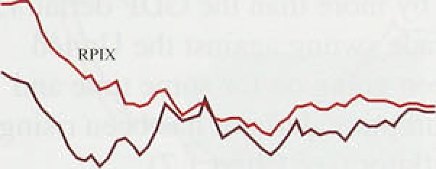

.RRX

_

- 0

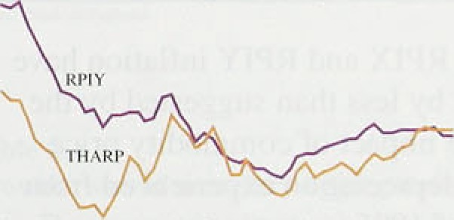

**THARP':und**

'

RPY



Chart 1.6

Pleasures oE underlying inflation

:Pc heritage.;i rtcrcasei-in.pnces;on.a.year curlier



**RPIX)**







To .deal with that problem the Bank calculates two measures of retail price inflation—the median and ‘trimmed mean’ .rates—whi ch exclude the impact of particularly large relative price changes. One-month inflation rates are calculated for 77 components of RPIX. These rates are then weighted according to the corresponding component’s weight in RPIX and ranked by size. The mean of the resulting distribution of price increases is the increase in RPIX in the month. The Bank’s trimmed-mean measure is the mean of the distribution after excluding both the largest and smallest 15% of price changes. The trimmed mean and the median are shown in Chart 1.6. As expected, these measures of twelve-month inflation tend to be less volatile than RPIX; they also tend to be lower, because the distribution of price increases is skewed upwards (hence the mean lies above the median). One drawback of such measures is that they ignore the large price changes which are an early warning of a step change in inflation.

*Recent price .shocks*

Shocks to the supply of, or demand for, panicular goods and services can affect the general price level and hence, temporarily, the measured inflation rate. Disaggregating the retail prices index can help to identify such shocks. In the.second quarter, concern over the safety of beef led to a fall in the supply of, and demand for. UK beef and a rise .in demand for other meat products. The price of beef fell by 2.5% between March and April, but the price index for all meat products (including beef) increased by 2.7&o. The net effect was an unexpected step increase in the general price level of 0.loo. In May and June, meat prices rose by about 1% and '/z&o respectively, broadly iC line with seasonal norms, so the Bovine Spongiform Encephalopathy (BSE) effect appears to have come thmugli fully in April and persisted thereafter.

Excluding meat; twelve-montli food price inflation has been falling, partly because of better harvests and lower paper and’metals prices .(two main elements of packaging **costs).** Also, tlie **.rise in ceasonal** fond prices in May lhis year was much 1ower'than the seasonal norm. Several

7





**Change ln expenditure deflators lmarket prices)**







I '106 Q I 2.It S.h 1.6 2.7 3.3 4.9 2.0

Ses«›nallv adjusted qumcrly pcrccitlagc changes

|  |  |  |  |  |  |  |
| --- | --- | --- | --- | --- | --- | --- |
| Qi ‹›• 9* r›.i› | cs | u i | tL6 | Lu | o.i | «.s |
| Q! *" W O.9 | 0.f | fi.4 | 11.6 | lk4 | 0.2 | 0.6 |

important administered.prices were put up in April; council taxes, for eKample, rose by 7,.4&r on average. The rapid increase in world cereal prices between March and M!ay (subsequently mostly unwound) is unlikely to have a significant impact on the UK price level. The short-mn outlook for retail price inflation depends to a large extent on the degree of discounting in summer sales; last year, it was greater than usual.

## 2 E end e e to

*k“huri* 1.7

Deflati›r-based measures of inflation





The **GDP** deflator is an index of the implied price of domestic value added, so in principle provides a .broader measure of inflation for domestically produced goods and services than the RPI. But the GDP deflator is less timely, less frequent, and prone to revision. As

Table I.C shows, it rose by 0.6Pp in 1996 Q1, compared with 0.5% in 1995 Q4 (revised up from the first estimate of 0.1%). In the year to the first quarter, the deflator for domestic demand rose by more than the **GDP** deflator,

" because the terms of trade swung against the United

, Kingdom. That has been going on for some time.andl explains why the consumption deflator has been rising faster than the GDP deflator (see Chart 1.7).

Short-run measures of RPIX and RPIY inflation have

###### begun to fall, although by less than suggested by the

, headline RPI rate. The impact of commodity price increases and sterling depreciation experienced from around the beginning of 1995 is starting to wear off. However, price indices which include estimates of owner-occupied housing costs are beginning to pick up.



Chart 2.1

**Growlh in M4 and M4 lending**

M4 rño'niiorJng rTinge Vintage chcngc* on a par earlier

— — 2'2

Broad money and lending growth were broadly unchanged during the first half of the year. Borrowing by industrial and commercial companies (ICCs) and consumer credit were still strong; personal sector borrowing for housing rose a little in the second quarter. Broad money trends still point to rising nominal demand growth this year and next.



—





Table 2.A

The growth in broad money (M4) remained high in the second quarter. Its twelve-month growth rate, shown in Chart 2,1, was still above the Government ’s monitoring range in June. The three-month annualized growth rate was.9.0% in June. lower than in March and December (see Table 2.A). As the previous *Report* explained, the

- J introduction of the gilt repo market at the beginning of the year led to a rise in the demand for, and supply of, money with no direct implications for economic activity. Adjusting for the estimated effect of gilt repos, the twelve-month rate of M4 growth was around the top of its monitoring range. By contrast with Q I, gilt repos

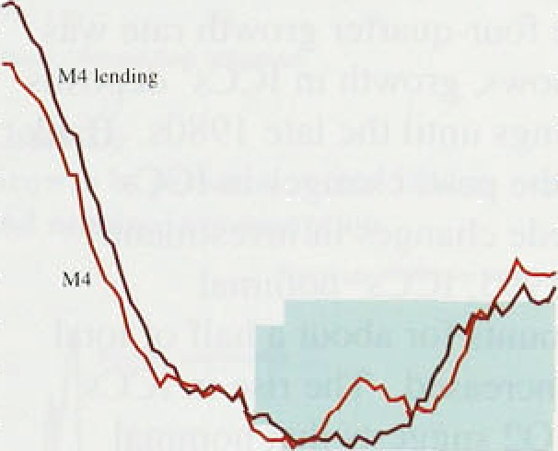

30

M4 .



Growth **rates of monetary aggregates‹**









.

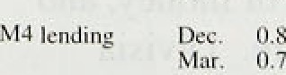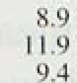

IO:4.

included in M4 fell slightly iIi Q2.

*Persniial secior*

.Individuals’ bank and building society deposits grew

|  |  |  |  |  |
| --- | --- | --- | --- | --- |
| Notts:and coin Dec. | 0.6 | 6:4 | ?.0' | S.g |
| :Maz., | 0.:4 | 6.4 | 6.4 | 6:3 |
| Api.. | 0.3 | 3.0 | 6:3 | 6.3 |
|  |  | 57 | :6.4’ | ’6:2 |
|  |  | J.9 | 7:8 | 0: |
| ’’Mw. | 0’.5 | 47 | 6:3’ | lF |
| .Apr. . | 0.5 | 8.0 | ..6.8 |  |

.quickl:y in 1995 and in the first half of 1996. The annual growth rate, shown in Chart 2.2, rose from less than 3% in 1994 to 6.8&o in 1996 Q2. As the chart shows. in the past, growth in deposits was closely linked with growth in nominal consumer spending. But, between 1994 Q4 and 1995 Q4, deposits rose relative to nominal



hire.: 0.7

9:0”

10-8 .

0?6

10:0..

10.0



.consumptioh. That build-up of deposits is consistent with the view that consumer sPendin8 will accelerate in

###### the second half of 1996 and in 1997.

› . Individuals also increased their holdings of other, less



as Chart 2.3 shows. Net ilows into!reta:i1 unit trusts.and national savings products in Q2 were more than twic.e as high as in the sam

period last year. main factors lay fiehind these increased ilows into 1ess liquid non-M4 assets. First, toia1‘personal ‹disposable.income growth has increased:



t”liari 2.2

tim» th in indi 'iduals’ **dey‹›sits** and

**n‹›rnintd cutlsumption**







Rrtail finttncial **inflows**

it averaged 1.7% a quartier between.1.995 Q1 and

1996 Q l, compared with 1.ldc a quarter in the previous

, two years. .Second, the first tranche of Tax Exempt

* • Special Savings Accounts (TeSSAs) matu!red in the early part of this .year. Most of the maturing capital was

- probably placed in follow-up TESSAs; but the

tax-free interest could not be reinvested in them. Third,

' low interest rates on deposit accounts probably

„ encouraged people to invest in potentially

higher-yielding instruments such as .unit‘trusts and

* ‹ national savings.

ICCs’ bank and building society deposits rose further .in the second quarter. The four-quaner growth rate was 12.1%. As Chart 2.4 shows. growth in ICCs’ deposits was subject to large swings until the late l980s. Bank research shows that, in the past, changes in .ICCs’

, deposits tended to precede changes in investment .t!1 Since the beginning of 1995, ICCs’ nominal

.investment—which accounts for about a half of total ' fixed investment has increased. The rise in ICCs’

* + deposit growth in 1996 Q2lsuggests that nominal investment growth could remain high.

*Other fi,ncincial* iitxfiiuii‹riis *(OFIS )(2 j*

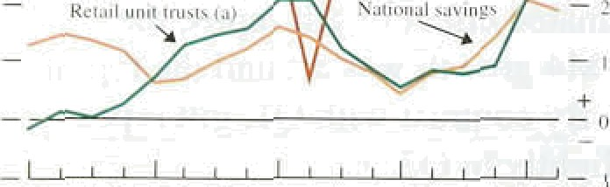

In the first quarter, OFIs’ deposits rose sharply because of the introduction of the gilt repo market in January. In the second quarter, OFIs’ deposits rose by just under 39r, with The second quarter



rise was the. lowest since. the end of 1”994, But OFIs'

##### deposits are volatile from quarter to quarter: .it is too

Cliari 2.1

Growth in ICCx’ deposits and nominal investment

soon to suggest that

the past year and a half is coming to an end.



over

 

 The Divisia measure of money aggregates the various components of M4, weighting them by their estimated liquidi.ty. .High-interest cieposit. accounts!are:often less 1iquifi.than low-iiiterest: aceOunis„ because of restrictions or.charges on the immediate wiHdrawal Sof ñioneyi and so have less welgiit in th#. Divisia.tireasure. Eiivisia’ money rose .by 2.39b in the seeond quarter, with.the

four-quarter growth rate rising’iiirther.to 10Sfi, !Chart 2,5

.shows iiow gro/Wth in Divisia .mo ey has usually been.





**Chart.2.5**

Growth in Divisia monei and nominal





closely, but not precisely, related to growth in nominal demand. Between 1992 and mid- 1995, Divisia grew less quickly than nominal demand. In contrast, over the past year, while Divisia money growth picked up, nominal

###### ‹domestic demand growth remained steady at around

, 5'/ % in the year to QJ. Part of the recent strength of

*' Divisia money may represent a recovery from that earlier weakness. Overall though. the continued strength of

” Divisia is consistent with the Bank’s central view that

.nominal demand will accelerate later this year and next.

— 10



Chart 2.6

Growth ih personal sector Divisia money











Personal sector Divisia money grew by I.9% in the second quarter, and 8.5& over the year. Growth in personal sector Divisia has been closely related to nominal consumpti:on growth in the past, as Chart 2.6 shows. During the early 1990s, nominal consumption grew more quickly than personal sector Divisia, but over the past year Divisia growth has exceeded consumption. In the first quarter, nominal consumption grew by I.89c, its highest rate for 2’/2 years: that could be early evidence of the build-up in personal sector liquidity leading to higher consumer spending.

*Nui mw* niritev

Narrow money growth picked up a little in June and July; the rise in June coincided with the Euro ’96 football .tournament. The twelve-month growth rate of narrow money, 7-1 &• in July, has been above the Government’s monitoring range of 09r—4% for the past three and a half years. Falling interest rates and low inflation have reduced the opportunity cost of holding

,cash, partly explaining the recent strong growth of narrow money.

**2.2 Credit demand**

M4 lending—bank and building society lending to the non-bank private sector—was £15.9 billion in Q2, compared with average quanerly lending of £14.4 billion throughout 1995. The twelve-month growth in bank and building society credit was 9.59c in June, compared with 8.7% at the end of 1995.

*Personal secior*

Toial,lending to individuals, which incliides lending from institutions .other than banks and building societies, continued at around its rate of!the past year. Its.

.twelve-montli groivth rate was 5.4& in June. Lending ’!8RG,ured **on,.property,** wliieb makes ,up about. 85% of

•› -› ' lending to in0ividvals,. continued to grow slowly. By



i '

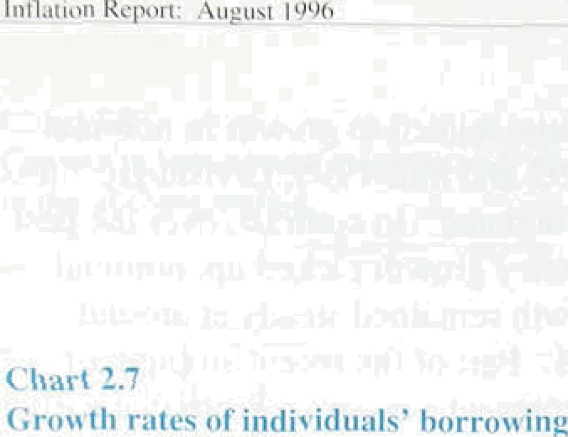contrast, short-run. measures picked up. in l.inc with rising trlrnover in the housing market in the second quarter. Consumer credit len‹iing which is riot secured *on* property—continued to gri›iv quickly, at a

twelve-month mite of around 14%.

As Chart 2.7 shows, mortgage lending has gi’own more

, slowly than other’ personal sectcir lending over the past 2 '/ year s. There are two main reasons. First, although lending secured on property is mainly for house purchase, it can also be used to finance consumption. ’Equity withdi dwal’, the diftei’ence between net mortgage borrowi •8 • nd housing investment, is a

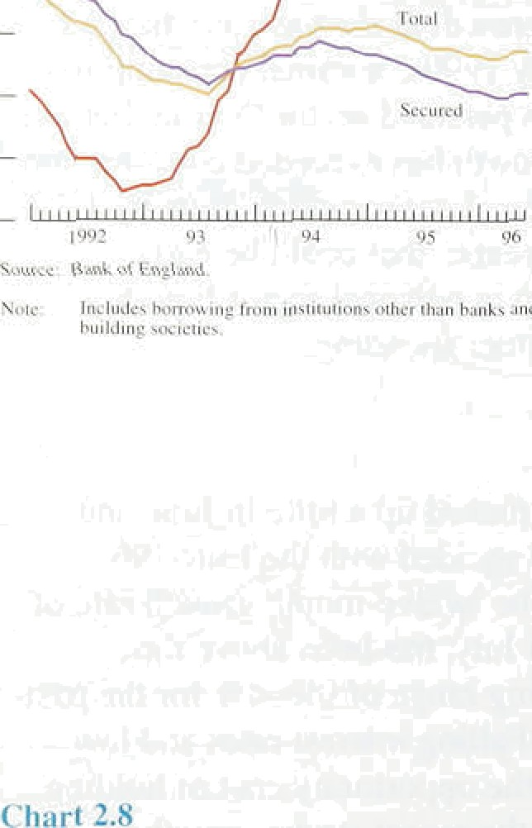' measure of this lending. During the late 1980s. when

consumption gi ew quickly, both equity withdrawal and consumer credit growth were strong. Over’ the past three year s, however. the subdued housing mai’ket has mcant that equity withdrawal has been negligible, so consumption has been financed largely by income or by non-mortgage boi rowing. Second, .recalling the adverse ex.perience of high indebtedness dui irig the early 1990s, people have been more reluctant to com.init to long-term mortgage borrowing, .ivouring .instead.consumer credit, which has a short payback period..



ICCs’ borrowing .frorn banks and building societies was

£5.4 billion in Q2, similar to the previous two quarters. Until the middle of 1994, ICCs were repaying bank debt. as they attempted to repair balance shéets damaged by the rise in borrowing in the late..1980s. In the 18 months to Jufie 1996, ICCs’ M4 borrowing totalled around



J29 bil.lion.

 Banks :and buildi.ng societies are not the only source of **ICCs’** fi.nance. At the end of 1995,.!about a quarter of ICCs’ sterling debt was wi.th capital .markets—i.n the form of bonds, .notes..and.cornmerci‘al. paper: .Chart 2.8 shows.’the recent profile of ICCs’ sferl.ing financing, .both debt and equity. .Over tire past two years; ICC:s.’ .ban.k

bo owing has increased. relative to::capital market finance—partly because!of.lower short-term interest rates, to which much ban.k bofiowifig is.linke‹i,.an‹i a!lso because .of anti:ncreased will.i.ngiiess.of banks to !• nd: Ifi the’fi'rst.half.of the yea!r.. ICCs’ sterling.bank and.

building ’society .borrowing was £1.I .7 billion; compfied w;ith ’£5.7 lbillion"raisefi.from éqp.ital’ ritarkets.

Strong borr.owing by ICCs over the!:past yéar..and’ a:half has.been..linked! to increased mergers. and acquisitions,



**Table 2.B**

**Gr‹›wth in bank and building society lending**

Persons ICCs OFIx Totul 5ccuw‹l Un urcd

pcrccn be chiingcs on a year c:irlicr

|  |  |  |  |  |  |
| --- | --- | --- | --- | --- | --- |
| I99Sg2 | 5.6 | It,TT | 7.II | I4.6 | 7,7 |
| g3 | 5.2 | It.4 | IO.4 | l'LB | 6.3 |
| Q4 | 4,9 | 12.8 | IN.9 | I4.9 | 8.7 |
| Q2 | 4.9 | 13.G | l S.â | 1 6.S | 9.5 |

Contributions io innual grn••ih in bank snd buildn S socie\y leftding (percentage points ) \bi

Q3 3.7 2.II 2.'\ 8.3



**Chart 2.9**

**Bank lending tu leasing companies‹*'**







_

1089 00 01 02 93 93 0r S6

(a) D•«•m•o‹Mson,llyWiumu.

**Chart 2.10**

**International syndicated loan spreads to**



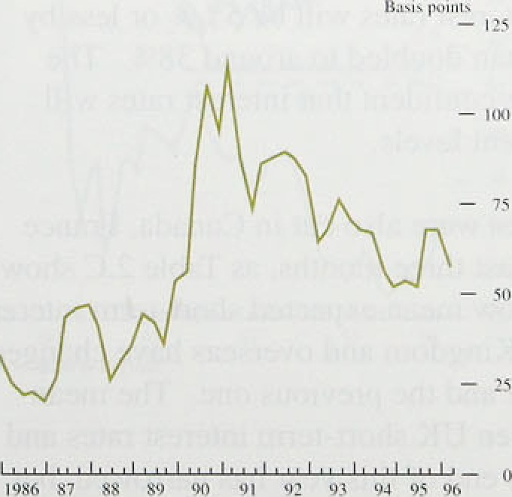





Mergers and acquisitions in the United Kingdom by UK companies totalled £32.1 billion in 1995, about four times higher than in 1994. Nearly 809r of’ this merger and acquisition activity was financed by cash—either through bank borrowing or drawing down deposits.

And in the first half of this year, activity was similar to

that in 1995.



Borrowing by OFIs from banks and building societies rose by l 6.5% in the year to Q2. Its strength in the first half of this year partly reflected the introduction of the gilt repo market. But growth in OFIs’ borrowing was high in 1995 too, as Table 2.B shows.

Borrowing by OFIs is often thought to be less directly linked to economic activity than borrowing by individuals or ICCs. That need not be so. In the year to the second quarter, about a quarter of’ OFls’ borrowing was accounted for by leasing companies. Chart 2.9 shows how bank lending to leasing companies has increased since the beginning of 1995. And, according to data collected by the Finance and Leasing Association, gross lending by leasing companies to

finance spending on plant and machinery rose by about a quarter last year, and rose further in the first three months of 1996. So some of the strength in OFIs’ borrowing may be linked directly to higher planned investment by ICCs.

#### 2 3 S l of e t

The supply of credit is determined not only by the demand for it but also by banks’ and investors’ willingness to lend. Lending spreads are one measure of this: falling spreads indicated that banks became more willing to lend over the past few years. Chan 2.10 shows average spreads over Libor paid by ICCs on loans from international bank syndicates. Spreads on loans made solely by UK banks are not readily available, but are likely to follow similar trends: separate data, collected for the Bank’s Representative Interest Rate survey, suggest that the gap between lending and deposit rates for ICCs fell over the year to 1996 Ql. As the chart shows, spreads were low in the expansion of the late 1980s, but widened in 1990 and early 199 l as banks retrenched and sought to improve their asset quality.

**From** about mid-1991, spreads narrowed as **banks’ balance** sheets improved and competition increased, **especially for high-quality corporate borrowers.**

l3



r"hart *. I I

xtvt\tng **three-mt›nth interest rtitr cx)H'‹'tati‹›ns'°'**



Banks probably became more willing to lend to retail cus:tomers too. Between July 1995 and J:my 1996, average variable mortg rates. fell  percentage points: over the same perifid official interest rates were cut by one percentage point, starting in

„ December. So personal slector borrowers benefited by ' " more than the cut in official interest rates implied.



## 2 4 I te t r the e h n e ate



Official short-term interest rates in the Unite‹i Kingdom were cut .by 25 basis points on 6 June. The cut had not been discounted in the financial markets: the day before

_ , , the cut, the short sterling futures market suggested that the next move in interest rates would be up.





Table 2.C’

**Changes in olfirial and krs'** interest i-utcs' '

In rhrcini ii t›gica l ordef

France I role ment t‹im *r iie* fi tune - 11) 3.60



-7fi

9.75





Chart 2.12

Sterling and overseas three-monih interest rate expectations‹•'

Chart 2.1 l compares the latest implied path of

short-term interest rates, derived from futures prices, with thosle at the time of the previous three *Inflation Reports.* Betweeri the May and August.Reports, market participants revised down their average:eKpectations of interest rates this year. By 2 August, when the data were finalised for this *Report,* the March 1597 contract implied a three-month interest rate of around 6% compared with 7% at the time .of the May 1956 *Report.*

The most widely quoted measure of.interest rate

exPectations is the rate implied by the. short.sterling future. That corresponds to the expected.or mean future. interest rate. But it is also possible to use option prices

to derive the market’s view of the probability distribution of future interest rates, .as the fiox on pages I W17 explains. As Chart C in the box shows, between

.the May and August *Jtepons,.;he* probability—implied by options pric:es that interest rates will be high’er than 6’/i% by March next year.has .fallen. And the, probability

three-month int ss by

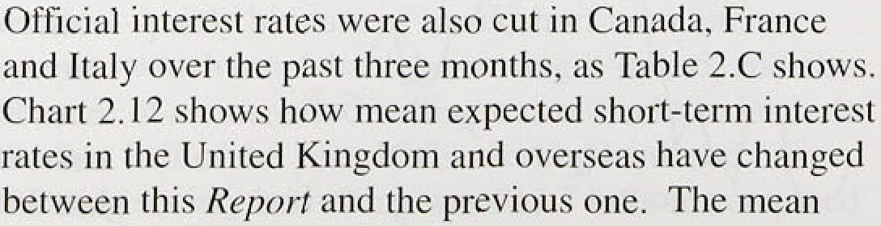

expects gaap ' e

but



es

.nextlMarch.more:than.doubled.to,around 38&o. The

##### .markettis now more confident”that ititerest.rates; wi!1l remain..around current levels!.



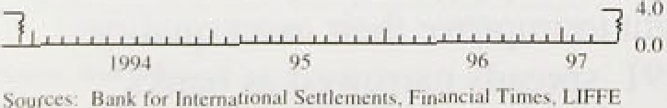



**Table 2.D**

**Implied..nominal forward interest** rates‹*›



*Long-,term intere.it* r ifex

Long-term interest rates in the United Kingdom fell by a little more than short-term rates over the past three months. So the yield curve has shifted down. A change

G# #h’y 8.2

’:’UoiicOJKJñg’dom %8



Ehart 2.15

8.G 8.0

R:8 8.7

7..4 7(

in long-term interest rates can be interpreted as a change in the expected path of short-term interest rates. assuming that inflation and real interest rate risk premia are unchanged. The fall in long-term rates since the previous Rrporrmeans that the market expects that

short-term interest rates in the United Kingdom will now be lower *on average* though not necessarily at alI

ttñplied nominal forward interest rates‹•›



- 7



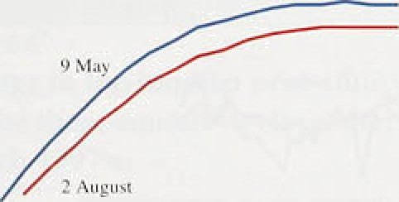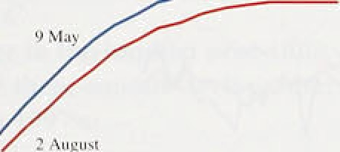

You Trc: Bank oF England.



**Chart 2.14**

**5terling effective exchange rate**

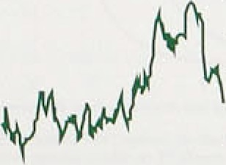



points—over the next ten years. From the yield curve, it

is possible to calculate the implied levels of short-term interest rates at various points in the future. These show that short-term rates are expected to be lower in the near term than at the time of the May *Report,* but the level expected in ten years’ time is little changed, as Table 2.D and Chari 2.13 show.(

The gap between ten-year gilt and bund yields narrowed by around 20 basis points to 156 basis points between the May and August *Reports.* So the bond markets still expect UK short-term interest rates to be higher on average than those in Germany over the next ten years. In part, these expectations reflect different shori-term cyclical positions. Looking at longer-term nominal implied forward rates avoids that problem. The markets

expect the level of nominal short-term interest rates to be closer in ten years’ time than they are now in the two countries, as Table 2.D shows. In other words. the gap between ten-year gilt and bund yields is mainly due to different views about interest rates in the short run. The gap between .interest rate expectations over the short run narrowed (see Chart 2.13): the UK implied forward interest .rate curve shifted down .by more than the German curve. But, as.the table shows, the gap between UK and German short rates ten years ahead rose

between the May and August *Reports* from 20 to about

70 basis points.

*The exclmnge rate*

The sterling effective exchange rate appreciated sharply in late May and:towards the end of June, but later depreciated; closi:rig.at 84.1 on 2.August, 0.4&o lower than at the.:ame:of:,the May *Report.* Chart 2.14.puts recent.move eiils..in:a longer-te:rm context.



turk:itii›u Rc]›i •ia: i.'met io‹i‹

. ..

Short-term interes.t!'r.ates in fhe **United Kingdom and .Germany: ,esti’mating market expectations**

M•irket expectations of short-tern;, ihterest rates provide policy-maker’s with useful information.

I nteresi .nite l’utures and bon‘d. markets (frorn ’which implied for ward interest rates c‹in !bo ciérived) convey iñtiH mation only oii market participants’

mean. or average, expec tation for interest mites in the

future—they reveal nothing âbput the probabilities that the mph ket attaches to othér poss'iblé outctiines (ui’ i:ixks) cithei side ct’ tlié inelan. Those

may provide additional important inft›rmati on—for ex,ample, adult whether the market Attaches: relatively high probabilities 4o the short-term. inter est rate being either shai ply higher or sharply lower than the present ie 'el in the neiir tcfiii.



lnforoauiion of the irarliet’s cuniplele probability distribtition for a t’uti e .shoi’1-term i.interest rate is 'implicit .jn tiptions pi ices. The prices at which opt ions trade contain information about the probabilities the market attiiches tti future events.

So the price of an interest mte future erin be used .to assess the rnai’ket’s JffCriii expectaiion of thui interest ratc when the.conti:act expires. But options on ihai .future can be used to assess the probabilities,attached by the mar kei to ‹i /riiiy‹ r¿/‘



,.f*fift’UJNC.\’ (or that inierest rate when the options expire.' › Imagine. an uption that give's its hcldo riyht to huy in interest rite fuiure at a particular price—the exefcise pi ice—and i›n a particular date in the future. how imagine a similar option with a Slightly hi!ghei, exercise price. The ilifference in thé

price‘of these two. options reflects. the value attached lo the ’ability to exercise the option.s when the price of the .underlying future lies between the two exercise prices: "That in‘tum ldepefids on the probabi.l.ify of the underlyi.rig futures price :lyin:g in

.this interval.

Thé charts below show probability disfy4butions °' for.

short-term .interest. rates at various .fiitiire-daies. They are implied by options’ on lhe’ LIFFE short. sterling future and tire.euromark fuuire.‹•› The

information committed in iriiplied distributions ran

.be aiy statistics. For.



illusWated

example,.Chart A shows how the mean, mode, and

1. 1. 1 fur'u'*‹ail' " By 8. 1 l99hi 'minsii dibinbuiion *of tuturc «uci ncex implied b o non

*i ’ Tlin;disriibuiiiiiis'°dérisedjyiii:fw'u rcpiiecntoiim rist•neuiml-investor: so if msrtci pwicipnnfs ure ri

.the lower *nd upper quirt:iles.Sof the,probabili!ty distribution for t:he:thrée- m. 9nth : sterling interest.rate iri Septémber 1.996 changed between 9 May.!anfi'

2 August (when the ;data were finalised.for the May‘ and August *In, flotinn Repo! rl! s.) .!••* :Chârt.Bi shows the. probñbi!1:ity. distributions for.both mates.

t’1iii i t .t

linJilied pruliiiliiiils. distribtitirni sii mummy emit ist ice t’t›r the I hi ee-nitiiit li sterling iiitercst rii I v iii Sepirin her **l99f»'.''**



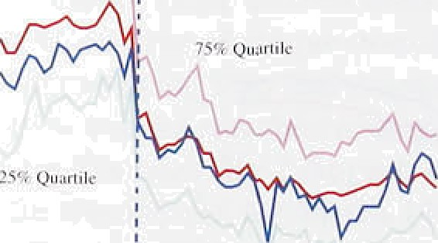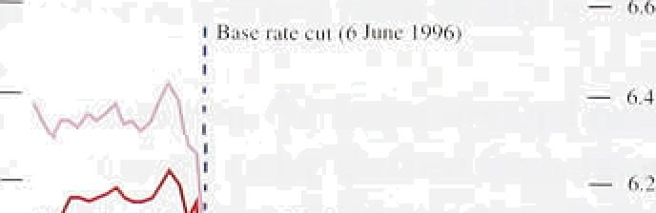

C’hiinge in the iiiiplie‹l **probiihility dis} i-ibuliuii**

f’ur the thr+e-n1‹›nth starling intii crt rat+ in







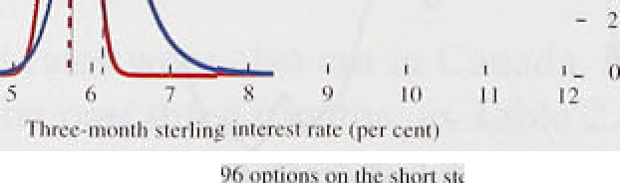

' •





Chart. A shows that the cut:in offieia:1. interest rates of 2J basis points on 6 Jun’e 1996 resulted in a fa’ll in

,the mean.three.-.inonth 'interest .rate for September of about othe same,ainouiit. But, at.the same tirñe, the gap between thé .mean ari‹i ’iiiode of fhe’prob.ability\

‹distribution closed, suggesting that ihere was, a lesser degree of asymrñetry in market expectations

.ifter tlie lcut than befofe. This..is also evifieiit i!n Chart B, which shows.titat..thé decreasé iin âsyminetry between .the probañilityi distributiori a1 the time of the’ May *jnflation* fieyor‘/ 'And 2 August arose from a shift in probability.Jrorñ rates between 6&o.and 8&• to. rates:betwéén 5'/•% snd 6%. .Chart B

:also shorts that market participants iwere less uncertain on 2. August than tttey were on S May about wtiere three-month. interest rates would be in September.'’The reduce‹i:tirñe to the contract's

.maturity date’aecounts for a.large part of lhat

.c hange.

Chart C shows tfie'change in the probability distribution..for.the.three-month.sterling interesl rate



Chu iigc iii i lie inn tilieii pi otiul7i1it\ ilisi i it›utiiiii t’nr the th rec-inr›ntli sterling interest rute in

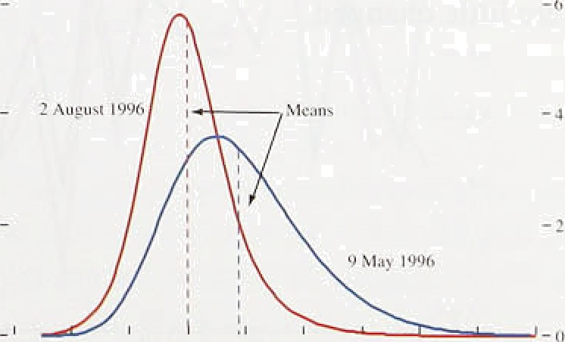

in: March; 1997 between 9 May and 2 August: lf.. shows that the fall ofi 87.ñasis.points in the rriedn interest ra?e.between.these.dates.reflected a move in probability away from outcomes:between fi.'f• nnd l.l%. and towards. outcomes.between 3'f•&.ahd

.6!fi . This.was a move from a relatively broad mnge of rates, some of which.were‘very much! higher than the theñ current rate. to a narrower rañge, of.rates:âround’or below.the.level of 5.75.% on 2.August: : The.probability of three-month



riite in â larch 1 997''







'i \i:q q ' : I ° -iqi :•usi. ’l'lie e jam i'i i ex pir ' . ›i i I '* 1 I srr'1i I’'" '

irileresl rates being at or below 5.75a in March 1997 more than dnubled from aroun‹i I G% to around 3d"/r between the lwo dates. while the probabi.1ity of three-month interest rates being.âi or below G°/ increased t‘roin around 23°/c to around

ñ 3°/r.

Chan D shows ihe change in the probabil.ity distribution for thc short-term Deutsche Mark. interest rate iti M arch 1997 between.9 May a nd

2 Augusl. It shows ‹i fall. in the mean interest rate of

1. 1 basis points, which was. un‹lerpinned by a. move in probability from outcomes between l ’/›%. and



between **2'/‹°/c** and 4’/,°/r.

That suggests that the narrowing gap1..,between expected sterling..and .Deutsche: Mark.short-.term. interest rates. in March l.S:97 since thi• May *iiii'laficin* Re/i‹›rrwas;undeyi:nned.by:different.shifts in.. expectations.„ The.fall’ in.:the:c.dxpectéd : short-term.!

.sterling. i:nterest rite reflecied, in part, the:maiket attaching .a lower probability to high f*tes .i.n ;he:iiear  rates some one to. five pé enta%e.

:poiiits.above the !evel. on 2 August). Bui the. smaller.

.fall i:i "the expected short-ferrri Deutsche Mark interest rate over the same period reil ecteil! :u *:iinallei* shift in probability frorn both tails of the distribution:

.to outcomes within orie..percentage point either:side’ of:the **.level.of 3:.25a on** 2 August.. The charts also

.show that.the market 1s:inore.confideiit about tile leyol .of German short-term rates:sorrie seven months

.from now.than .it is aboiit,:UK Craies..

l:7











- 75



lt is possible to calculate .an implied path for the exchange rate over .the next ten years by comparing UK and .overseas interest rates and assumiiig tfiat currencies move to equalise expected returns across countries (uncovered interest rate parity). Although the spot exchange rate depreciated betwqen the May and August *Reports,* the ‘expected’ exchange rate in ten years’ time rose by about 'hi or so (see Chart 2.15); interest differentials now imply a less steep depreciation of sterling. That is because UK interest rates are expected to be a little lower relative to those overseas than at tire time of the May *Report,* particularly in the near term.

The change in view about interest rates may reflect a.fall in expected UK inflation relative to that overseas: average RPI inflation expectations derived from the gilt market have fallen—particularly for the next three and five yeurs, as Chart 2.16 shows.(

( I xouni ng u»co 'c reil iiiicrcst rum peril}

Chart 2.If›

.-I verage inflation expectsti9rts *'

O fi 'e Ii'car xt

O 'cr ite ncxi

## S2MS a

###### „ The continued strength of broad money signals higher

, , nominal demand growth this year and next. Although

, , that relationship is imprecisle, the further build-up in private sector liquidity poses risks to inflation: broad money is growing faster than is compatible with the

‘’* inflation target in the long run. Short-term interest rate

###### and inflation expectations derived from financial

' markets have fallen since the May.Report; longer-term expectations were little changed.

3:0

o.o



18



Chain 3.1

GroMh of real GDP and domestic demand



-4

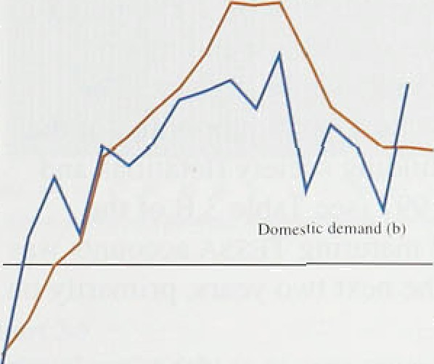

— 2

t'992 93 'N 95 96

# OVerview

Real GDP, at factor cost, is estimated to have grown at

.around '/i9r in each of the six quarters since the start of 1995, a lithe below its long-run trend. Annual GDP growth rose between 1992 and 1994, peaked at just over 49a .fit the end of 1994, then fell to just under 2% in 1996 Q2 (see Chart 3.1). Domestic demand growth also peaked at the end of 1994, then fell, but rose again in the first half of 1996. Net exports increased annual GDP growth throughout most of 1993 to 1995, but reduced it in the first quarter of 1996.

Real M broad money deflated by the increase in retail prices excluding mortgage interest pa ments—grew by

**Chart 3J**

Growth of nominal GDP and **domestic** demnndi•›



7% in the year to 1996 Q2. Changes in real M4 growth have typically preceded changes in real. domestic

demand growth over the past 30 years, so the recent rise in real M4 growth suggests a rise in real domestic demand growth over the next year or so.

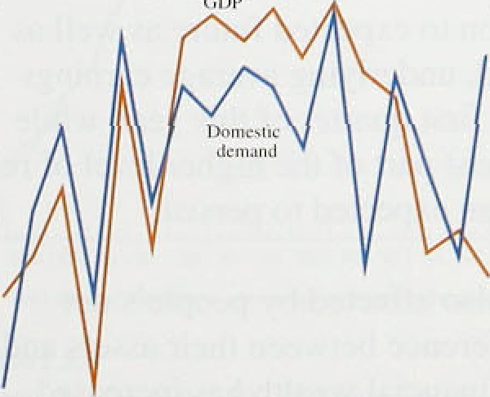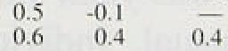

|  |  |  |  |
| --- | --- | --- | --- |
|  | | _ „ | Nominal GDP growth was around 4% in the four |
| p |  |  | quartets to 1996 Ql, less than would be consistent |
|  | *•• | '° | with inflation at 2'/›% and real GDP growth at its |
| _ |  | _ „ | long-run trend rate. But nominal domestic demand |
|  |  |  | was around 5'/•% higher in the first quarter of this |
|  |  | •° | year.than a year earlier and was accelerating  (see Chart 3.2). |

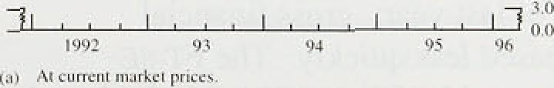 **3.2 Domestic demand**

Real domestic demand is esti.mated to have increased by 0.9&o in the first quarter of 1996, twice as much as in the previous quarter. In particular, both consumption and investment accelerated. Table 3.A shows the

.cpntributi9n to GDP growth over the past two years made by!the main eKpenditure components. Despite growing.below its long-rim trend rate last year, consumption was .the main source of GDP growth. According to the ONS, directly .measured.stockbuilding was equivalent.!to around '/4&» of GDP in the year to



lsn:it ion Repori: August i99r›

*Personal sector demand*

Consumer spending accelerated in the first quarter of 1996, when it amounted to fi116 billion. The real increase in the first quarter is estimated to have been 0.9%. Personal income was boosted by .the regional electricity companies’ (RECs) rebate of around £50 to each of its customers and by a special dividend payout arising from the merger between Lloyds Bank and the TSB. Together these were worth around £2 billion.

Consumption of durable goods rose by 2.1to, much faster than in the previous quarter; spending .on non-durable goods accelerated only.slightly. The

previous *Report* argued that a small proportion of the 'windfall gains’ from building society flotations and takeovers in 1996 and 1997 (see Table 3.B of the previous *Report )* and of maturing TEsSA accounts was likely to be spent over the next two years, primarily on consumer durables.

Chart 3.3

Crrowth of individuals’ holdings of real M4‹•›

Consumption is influenced by households’ expectations of their future disposable income, which is unlikely to have been affected by one-off payments in 1996 Ql. So why did consumption accelerate? First, disposable income is affected by taxes. The tax cuts announced in the November 1995 Budget were equivalent to around '/i& of personal income. These could have been considered as an addition to expected future as well .as current income. Second, underlying average earnings growth increased in the first quarter of this year, while **RPI** inflation fell. At least part of the 1iigher level of real earnings might have been .expected to persist.

Third, consumption is also affected by people’s net wealth—that is, the difference between their assets and their liabilities. Gross financial wealth has increased since the beginning of last year; gross financial liabilities have increased less quickly. The FT-SE

All-Share index increased by 3&c in 1996 Q2. Although it fell in July, it was still 10% higher than a year earlier. Last year, 189o of the.personal sector’s.gross financial wealth was held directly as equities.

Another important element of fioiiseholds’ wealth is their

* •• money, either In cash or ip..bank and bullchng,society accounts. These holdings rose rapiiJly last year and in
* " the first half of this. year, but.the. growth rate is not: historically unusual.! .Irtdividuals'ho1tlitigs. of real M4," after taking ti to ance**unt** m*reasei){n **retai].** prices, f*s* by 4%‘ln the year ter l99b..Q2. **This.** was **;nuch** stronger than qt **any** time in thy part five **y‹;ars„ as** hati 3.3 shows„but lower-than-werage growth in the 1980s.

20

**Chart 3.4**

**Personal sector income gearing'.'›**



Personal sector gross interest payments have fallen recently, partly because of lower interest rates. Chart 3.4 shows that interest payments as a proportion of

’” disposable income were low in 1996 QI relative to the

* + - › previous twelve years, and the ratio is likely to have fallen further in 1996 Q2. The debt-to-income ratio. too,

” has fallen since 199 l, as shown in Chart 3.5. So

i‹» consumers may be more willing to borrow now than in the previous five years.

' • In summary, households wealth has improved, their

_ expected future income has also probably ri.men, and debt ” burdens have fallen. This suggests that consumption is

likely to continue growing at above its long-run average

" ' ‘" ‘" ” ” "‘ rate over the next two years.

ai l merest puynic nis u a percentage of pcnun*l dis;uxsablc iiicunic.

**Chart 3.5**

**Personal sector debt-to-income ratio'*'**

**Chart 3.6**

**Grnwth of retail** sales and consumption

275

Retail sales volumes grew by 1.3% in 1996 Q2, more than three times as fast as in the previous quarter.

Although in the first quarter retail sales growth was much weaker than consumption growth, the picture may have been distorted by a chanp•ing spending pattern around Christmas, so it is useful to look at growth over two quarters together. Between 1995 Q3 and 1996 Q l retail sales volumes grew by I.29r while consumption grew by 1.6%. Chart 3.6 shows that over the past 20 years there was a close correlation between consumption growth and retail sales growth. And there has been no long-run trend change in the proportion of consumption represented by retail sales, so there is little reason to think that the link has changed (althoug•h it was temporarily distorted by the introduction of the National Lottery at the end of 1994). Average quarterly retail sales growth in the first half of this year was 0.87c: this is consistent with consumption growth in 1996 Q2 remaining above its long-run average.



— 3

i973 75 go 86 90 95



Retail sales and consumption in the second quarter may have risen exceptionally because of the European football championship: retail sales volumes rose by l.3&o in June. Alcohol and clothing sales were especially high. But the net effect on domestic consumption was probably small: other expenditure, such as going to the cinema and theatre, may have fallen. The biggest effect was probably on spending by tourists, which is assigned to exports in the National Accounts. The English Tourist Board estimates that an extra 250,000 tourists entered the United Kingdom in June, spending an average of at least £500 each. This would have added 'lake to exports.





Re‹il pi’ivate investment grew by 3% in the first quarter of this year-—its fastest growth for seven years. It was 3'/. 9c higher in 1996 Q l than ‹i year earlier, valued .at 1990 prices, bin was 8'/•% higher in current prices. The nominal private sector investment-output ratio rose, and by more th‹in the ratio measured in real terms.



ln.vestment behaviour has varied considérably .across sectors recently. Manufacturing, mi.ning and quarrying investment fell for the seclond consecutive quarter in 1996 Q1. But investment by utilities grew rapidly. The pattern of growth has changed. since the mid‹ile. of.last year (see Table. 3.B.). The recent increase in investment expenditure has been .entirely due to spending on plant and machinery and on vehicles, sh.ips and aircraft.

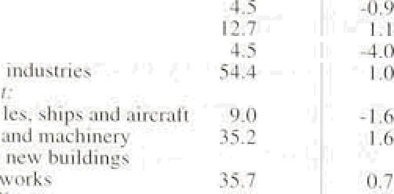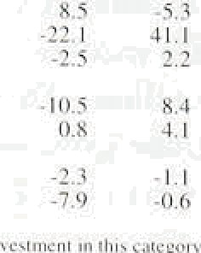

Residential and non-residential construction-related investment fel.l in the year to 1996 Q1. In 1995 as a whole, total investment valued at 1990 prices fell by 0.19c, according to the latest ONS estimate (lcompared with an estimated fall of 0.7% at tfie .time of the

May *Rep ›rt ).* The estimate of private investment growth in 1995 was revised down, but this was more than offset by a higher estimate of general government investment.

The relatIve price of investment goods is .estimated to have risen since 1994, but is historica:ll.y low (see Chart 3.7). That should act as an incentive to invest.

But the investment-oiitput ratio, both in current and constant prices, has fallen si.nc1e the end of.the 1980s. So the incentive from relative price changes has not yet prompted stron!g real i.nvestment growth. The market valuation of capital rélative to the replacement cost,of capi.tal is k.nown. as the .valuation ratio or.Tobi.n’s ‘.q’: That ratio was considerably higher: thañ one in

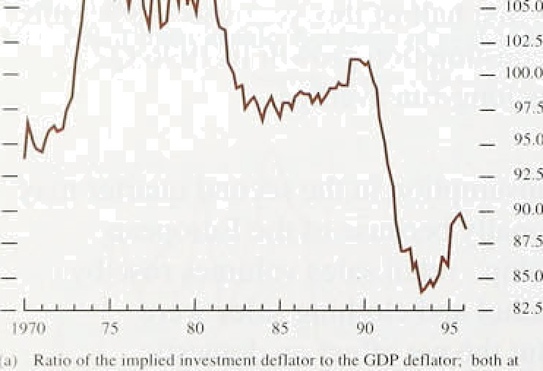

1.996 Q1., according ,to the Ban!k’s estimate, which .means

.that it should have been profitable .for firriis.to issue .new gquity to finance the !purchase of capital. goods. B.ut firms’ .non-physical ,assets may be:.becom.i.ng iñcreasingly important (for example, intellectual .propeny ri.glits. i.n the

.computer .i.ndustry): These assets would not!be pickets up. in .the Ban!k's measure of Tobin’’s :'q’, which .measures

e kplacement cost. bf physical. asiets only.: So .the

£t S e **fl O**

.in nst in **hyurcal..** assete:

pureh **engf**

phnysfeal '

assets are not included’in the statistical defiliition of investment.





Firms have an incentive to invest when a shortage of capacity is likely to limit .future output growth. The number of manufacturing firms expecting plant capacity

to limit their output over the next four months was above .its long-run average in the CBI’s Industrial Trends Survey for July. In the service sector, where recently output has been growing more strongly, survey evidence of capacity utilisation suggests that firms have a strong incentive to increase investment.

**Chart 3.8**

**Hñuse prices end housing turnover**

Not all the data point to stronger investment growth. Retained earnings of industrial and commercial companies (ICCs) were lower in the first quarter of 1996 than the average of 1994 and 1995. Annual gross trading profit growth .has slowed since 1994 while dividend and interest payments have risen sharply.

I H —

110.—.

90 —

 

_ o Q

H ué m f(a) - 215

0



1989 90 91 92 93 94 95 96

Private residential construction activity will probably pick up in the second half of this year. House prices have risen recently (see Chart 3.8), and net lending secured on dwellings rose in the first half of this year. Housing turnover rose a little in .the first half of this year, but private housing starts and completions together were weaker in the three months to June than in the previous three months.

*Stockbuil,ding*

The August 1995 *Report* suggested that some

Sources: .Halifax,Bullding' Swe•ij and:'OHS.

tax Tumo F.'Measured/by.:pgrecii!a;rs.del ivered. 'Tfic'dat arc. moied



destocking in 1995 could lead to a general showdown m GDP growth in the second half of that year and the beginning of this. In the event, stockbuilding remained very high for most of last year. But lower stockbuilding probably depressed growth in the first half of this year.

Around a third of the large increase in stocks in 1995 Q4.and 1996 Ql was accounted for by the statistical alignment adjustment. That adjustment is made by the ONS to the expenditure measure of GDP so as to make it tally with the output measure. ' ’The alignment adjustiñents between 1993 Ql and 1995 Q4 were revised by an absolute.average of £424 million a quarter, in 1990 prices, between the first estimate made by the ONS and the latest estimate made in June this year. The equivalent revisions for directly measured stockbuilding (that is, excluding the alignment

' adjustment) were £351 million a quarter. So in the

:recent.past, bo.th the alignment adjustment and.directly

measu:red stoekbuitñing have been subject to lgrge

.revisions. **The** alignment adjustment is **include‹i** in

:(’I).' fizttber ift..f0nn...etisn.bscpr es.ava‹iabie*.more:weight.is.:pIaced.on the



stockbuilding data only because of the difficulties in measuring stocks not because the ONS have additional information that lend it to believe that stocks data are being under or overrecorded. So it is probably best to analyse stocks excluding the alignment adjustment, but there is a possibility that directly measured stockbuilding has been underrecorded.

Table 3.C shows that stockbuilding in manufacturing. which accounted for most of the rise in stocks last year, was considerably lower in 1996 Q l than in 1995.

Stockbuilding in the distribution industries (which hold about a third of total stocks) was around its long-run average last year, but increased significantly in 1996 Q1.

The significance of the recent increase in stocks for future output depends on whether it was voluntary or not. Firms want to hold stocks to avoid losing revenue and potential customers, as they would do if they could not satisfy orders, and to avoid disruptions to production through insufficient raw materials or components. The amount of stocks they need to hold for these purposes is likely to increase as sales or output rise. Chart 3.9 shows the ratio of stocks to sales. Over the long term, stocks have fallen relative to sales, reflecting improved stock management techniques. However. stocks rose relative to sales between 1995 Ql and the third quarter of that year, but subsequently stabilised.

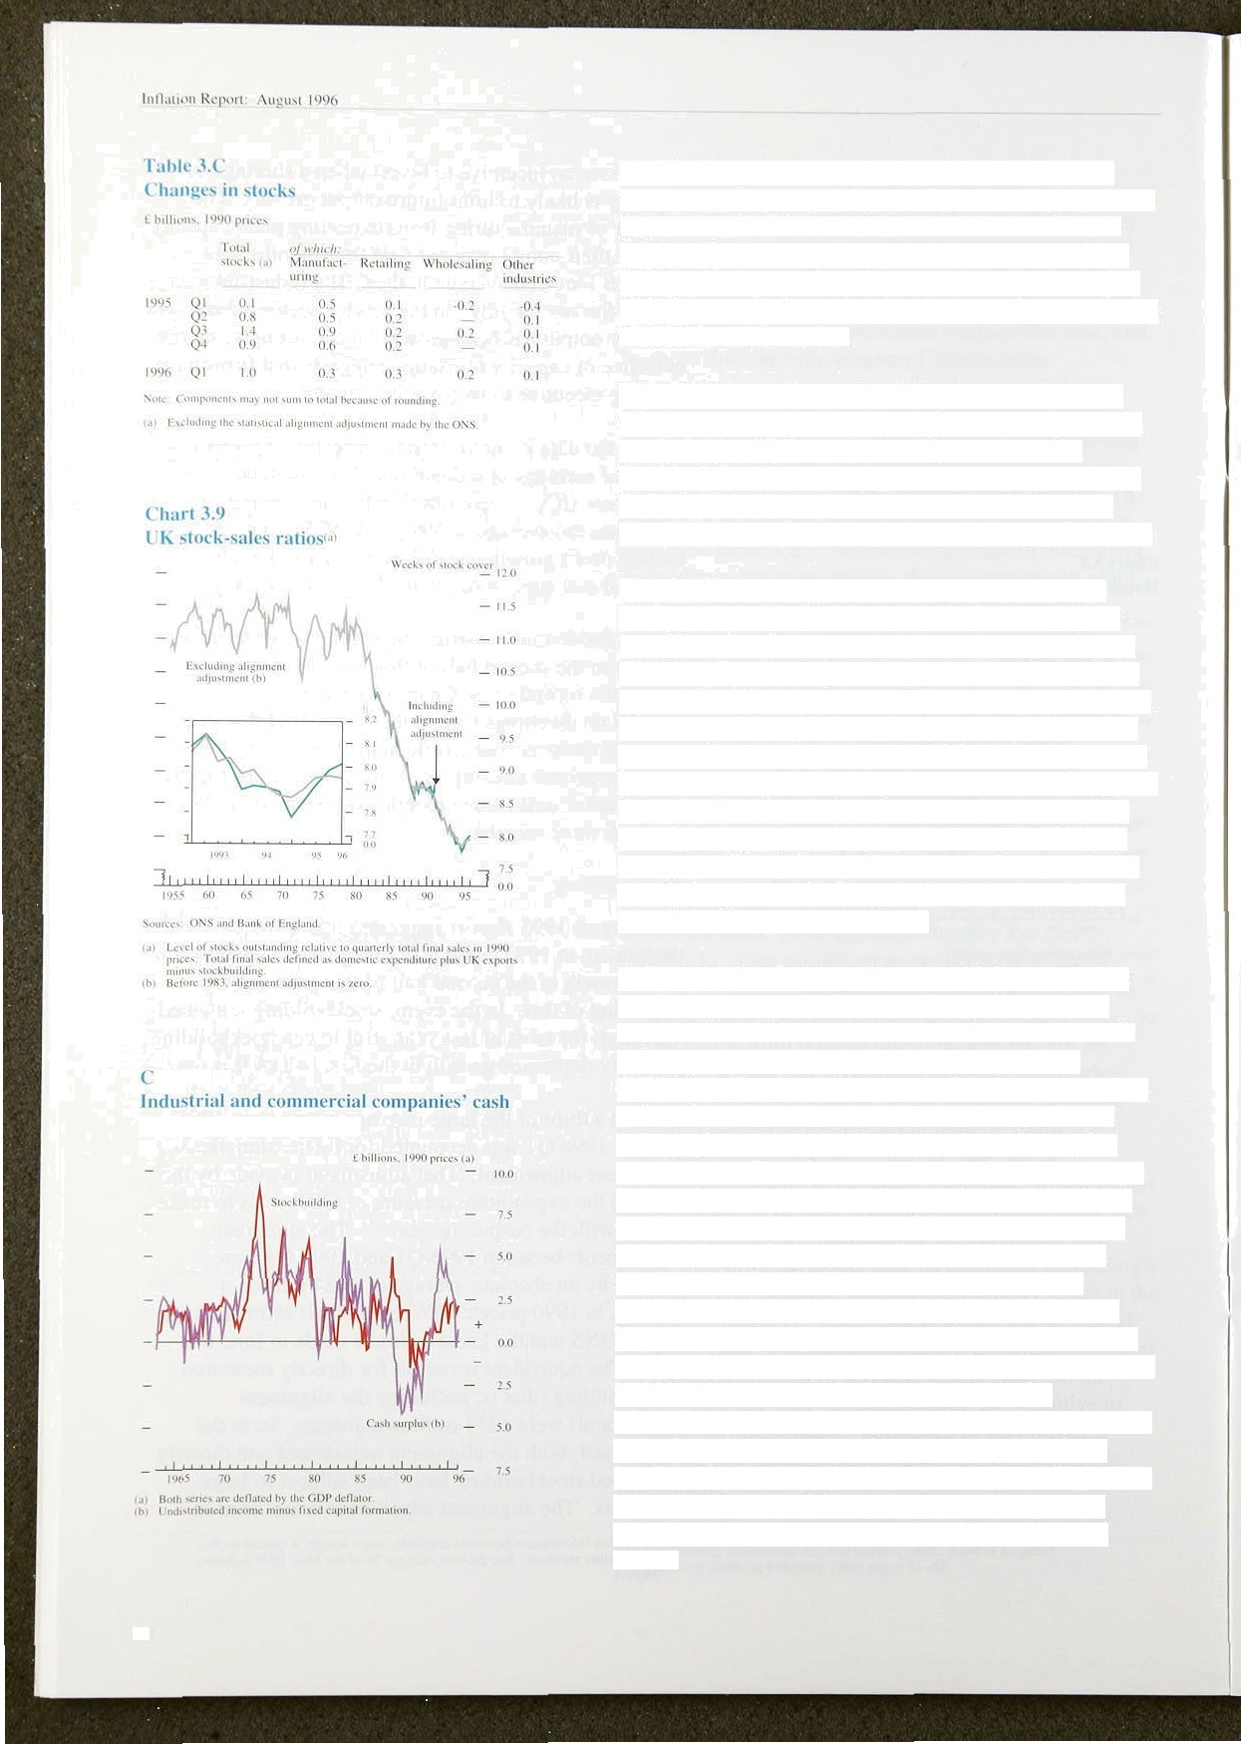

hurl 3.10

**surpl us rind stnckhuilding**

24

A firm’s desired holding of stocks will depend also on financial constraints. A firm may be willing to hold more stocks relative to sales because it has excess cash holdings. Alternatively, if a firm faces cash-flow dIffiCulties, it may liquidate its stocks—it may not want, or be able, to borrow more. One measure of a firm’s cash surplus is its undistributed earnings after capital expenditure. Chart 3.10 shows that in the past there has been a close relationship between this measure of cash surplus and stockbuilding for ICCs (which hold about three quarters of all stocks). Some of the large cash surplus in 1993 and 1994 was used to repay bank borrowings which had risen rapidly in the late 1980s.

The rest may have been used to build up stocks relative to sales. Recently, ICCs' cash surplus has fallen sharply: in 1996 QI it was £0.7 billion, compared with

£4.1 billion a year earlier, so the rise in the stock to sales rntio since the beginning of last year may have been involuntary. But firms’ cash surpluses were still positive in the first quarter of this year, so there is not strong pressure from this source to reduce the total level of **stocks.**

Chart 3.11 Adequacy ot’stocks‹°

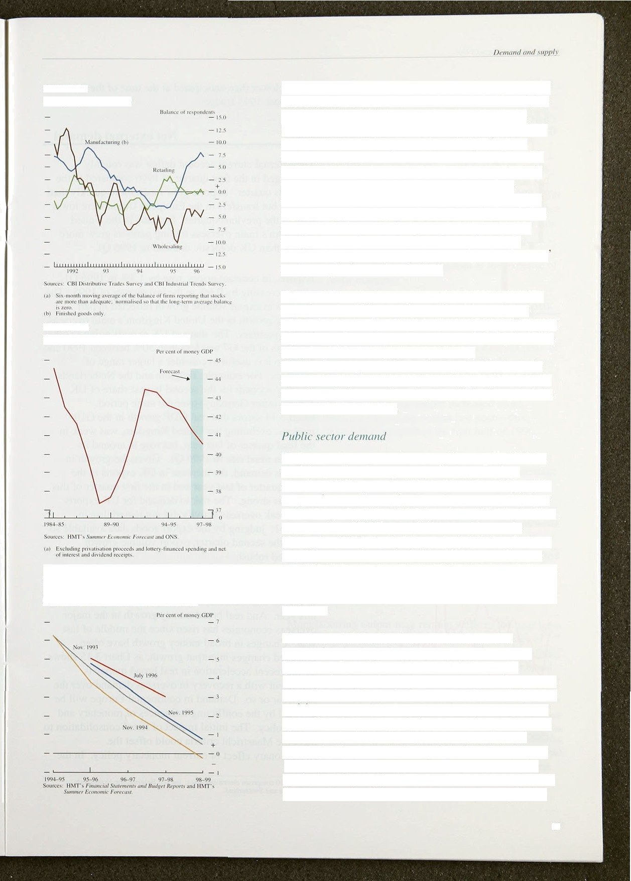

Chart 3.12

**€'eneral government expenditure •'**

**Revised forecasts of the general government**

CBI surveys include a question about the adequacy of a firm's stocks, The answers can be useful in identifying particular sectors which might have built up stock s involuntarily. There is a contrast between wholesalers’ and manufacturers’ responses to such questions, as shown in Chart 3.11. Over the six months to June this year, the balance of manufacturers reporting that their present stocks of finished goods were more than adequate was higher than its long-run averaq•e. But in wholesaling, firms reported that their stocks in relation to expected saJes were lower. So, although it seems likely that manufacturers will seek to reduce their holdings of stocks in the immediate future, wholesalers

stocks may be lower than desired.

Taking all these factors together, it is not entirely clear why firms should have e/t‹rsrn to increase stocks so quickly in ihe year to 1996 Q1. Excluding the alignment adjustment, the stock to sales ratio rose initially in 1995, then stabilised in 1995 Q4 and 1996 Q1.

Weaker-than-expected demand was probably the main explanation for the build-up of stocks in 1995. Looking ahead. stocks in manufacturing may fall as firms seek to improve their cash flow.

Real general government consumption rose by 0.1 Mr in the first quarter of this year. General government investment fell by nearly 15%, but investment by public corporations rose strongly. In real terms. overall public sector demand fell in 1996 Q1, and was 2'/•9r lower than a year earlier. HM Treasury’s Summer Economic Forecast, published on 9 July, projected further declines in public sector demand relative to **GDP** over the next two financial years (see Chart 3.12). The projected large falls in government investment are planned to be partly offset by private investment under the Private Finance Initiative.

Fiscal consolidation has been much slower than expected at the time of the November 1994 Budget.

This was reflected in revisions to HM Treasury’s forecasts for the deficit in the Budget last year, and in its latest Summer **Economic** Forecast (see Chart 3.13). The revisions were mainly due to higher-than-expected real expenditure last year, partly because cash spending was close to projections while inflation was lower than expected. The amount of tax paid in the financial year 1995/96 was also unexpectedly low in relation to the level of activiy— egective tax rates were lower. HMT’s Summer Economic Forecast projected that they would

25

!M. it ion ReportA: bu ust 1006

t’hart fi.14

t*rnu th of o• ersvas real CiDPi°i





Chari 3.lv

###### remain lower than anticipated at the time of the November 1995 Budget.

**3.3 Net external demand**

The external current account deficit was roughly

' ' unchanged in the first quarter of 1996 compared to the "'• previous quarter. Imports grew much more quickly than

‹ exports but transfers to the European Union were lower

, than in the previous quarter. Demand in the United Kingdom’s main overseas trading partners grew more

slowly than UK domestic demand in 199fi Q l. ’

Exports, in constant prices, rose by l.3% in 1996 Q1, after increasing by 0.6% in the last quarter of 1995. The increase in export volume growth reflected in part stronger growth in the United Kingdom’s main overseas trading partners. The share of UK exports going to other members of the G7 was less than 50&• between 1990 and 1995, so it is useful to consider a larger range of countries. For example, Belgium and the Netherlands together account for the second largest share of UK exports (after Germany) over the same period.



Chart 3.14 shows that real GDP.growth in the G10(1) markets, excluding the United Kingdom, was weak in the final quarter of last year, but rose to around its long-run trend rate in l99ñ Q1. Given the growth in

overseas demand, the increase in UK exports in the fourth quaner of last year and in the first quaner of this year was strong. The risk to demand for UK exports

from weak overseas activity did not materialise in

ti rowth of overseas real UDP and real money“' › 996 Q1: judging by the export goods data available so

far for the second quarter, export volume growth remained robust.



— - 0;0’

— 2.$



Sources: Bank for lniemzi ronsl Sctilcmcn i* end Dmas'ircim.

la} cco Unitod /tingdom weighted:@ ih< 1are of



Compared with the previous *15* years, real.interest rates in France and Germany were rery low in the first half of this year. And real broad money growth in the major. overseas economies has risen since the.middle of last

year. Changos:in broad money growth have often preceded changes in..output growth, its Chart 3: l5 shows. So the recent acceleration in.cea1 broa‹i money is consistent with a recovery in overseas ‹ietñand over,the next year or so. Demand in continental Europe will be affected by the conflicting influences .of monetary añd hscal policy. The initial impact.of fiscal consolidation to

:meet tire:Maiatrichticr1feria.cou1d’offset the expansionary.effect of currént monetary-policy. In tire





United States, dome.stic demand grew by an annualized

rate of 4.2r' between 1995 Q4 and 199ñ Q2. Gr(›wth

there may slow down to its long-run trend rate of 2.Str .

Net extei nal demand depends on i in ports as well as exports. Import volumes grew by nearl y 3% in

1996 Q I, compared with ().9°/r bit wth in U K domestic demand. Increased international specialisation has led to a trend increase in import penetration since 198(L B ut import penetration has inci eased unusualJ y quickly since the beginning of last year , despite the i eat exchange rate

depreciation at that time. Weak domestic demand overseas could have pi ompted foreign firms to seek volume growth in thc United Kingdom at the expense of’ reduced profit margins.

3 4 0 t ut

Whole-economy annual output growth, valued at 1990 prices, is estimated to have slowed l’i’orn a recent peak of 4.3% in 1994 Q4 to l.8Ur in 1 996 Q2. Whole-economy output is estimated to have increased by 0.4U‹ in 1996 Q2, but excluding oil and gas extraction, output rose by only 0.37c. Service sector output inci’eased more quickly than manufiactui’ing output last year—this pattern o1’ growth continued in the first half of 1996.

According to the initial estimate by the ONS. the efteci of BSE reduced growth in **GDP** by about O.l percentage point in the second quarter, and growth in agricultural output by between five and ten percentage points. The effects of BSE are likely to be larger on agricultural supply than demand. The overall demand for agricultural products is unlikely to have fallen, even though the composition of’ that demand will have shifted away from beef to other tood. But the supply of agricultural products, in the slioi t run. will have been reduced by the slaughter of cattle.

Manufacturing output may remain weak in the near term if firms in that sector seek to reduce their holdings of stocks. That could slow output Rrowth in the rest of the economy if, for example, manufacturing firms demand less output from services or construction industries or if lower manufacturing employment reduces consumption. Chart 3.16 compares growth in manufacturing output with output in the rest of the economy over the past

35 years. Although both have tended to move together. manufacturing output growth has been more volatile and there have been periods when manufacturinp• has been much weaker than other sectors of the economy.

?7

lflBatitift R‹iJ3'ort: A u uxi 1996

t’hai’i 3.lfi

t i **ri›«’lli of nianutarturiug ;ind**

nun-niunuf:icluring uutput

l’e rccnr 'e ch• n c on a 'c'





— i0.0

The degree of spafe capacity will influence whether firms decide to respond to increased demand in the short run by raising their prices or increasing thleir output.

CBI surveys suggest that the number of manufacturing firms expecting plant capacity to limit output over the next four months was above its ten-year average in July. But capacity constraints may be more pressing in the service:sector. The number of service sector firms working at full capacity .in 1996 Q2 was at its .highest since the question was first asked in 1989, according to the British Chamber of Commerce. So short-run price pressures may be more prevalent in the service sector.

1. 5 Su a

GDP continued to .grow at a little below its long-run trend rate in the first half of 1996; in Q1, domestic demand accelerated as consumption and investment grew strongly. Consumption growth is .likely to remain strong over the next two years. Debt burdens have fallen and wealth has increased. Tax cuts and a rise in aggregate

.real earnings may have raised households’ expected future income. And building society windfalls and maturing TESSAs should provide a small temporary boost to consumption of durables.

Last year, investment in manufacturing grew by more than in any other industry. But more recently, total investment has grown despite lower manufacturing investment. Investment in .other industries .could grow more quickly than in manufacturing over the neKt two years. Capacity constraints are probably more pressing in the service sector than in manufacturing, an‹i construction-related investment should be stimulated by the recent recovery in the housing market. Although government investment is planned to fall over the next two years, overall investment should grow more quickly than GDP.

Stocks, excludi!ng.the alignment.adjustment, rose relative to total final sales over the.year toel996..Q1. Although the absolute.level of stocks. may no.t.fal.I, GDP growth may be restrained by lower.stockbuil‹iing for the rest.of th!is year.



Claimant unemployment continued to fall in the second quarter, at almost the same rate as in the first three months of the year. But a rough estimate of the gap between total hours worked and the potential number of hours people would be willing to work has remained fairly constant over the past year, suggesting that the

.labour market has not tightened much over that period.

Post-tax annual real hourly wage growth—the ‘consumption wage’(' —picked up to 0.6% in the first quarter, the latest quarter for which data are available, after no growth in the year to the last quarter of 1995. In the second quarter of this year, the consumption wage probably rose sharply as a result of personal tax cuts in the November Budget, which took effect in April. The consumption wage for manufacturing workers was 4.2% higher in May 1996 than in the same month a year earlier. The real hourly pre-tax wage—the ‘product wage’(2 inCre aSi d by l. 2% in the year to 1996 Q1. after rising by 0.69 .over .the year to 1995 Q4.

**Table 4.A**

**Total employment** growth‹•i‹•›

Châeeea oyer pcrioJ-sltown: thousands



|  |  |  |
| --- | --- | --- |
| kabour Foise:Slin'ey nic•asun•:tcp | 77 36 | 98 57 118 -3.4 |
| W.orWf»‹t:u in.EmplpJm$qt niencure | 22 -2 | —= 79. -7 l . . |





Table 4:B

**G.rowth ifi. fiill-iiine and part-time work over tire**



#### 4.1 Demand for labour

According to the Labour Force Survey (LFS), the number of employees fell by 34,000 in spring 1996,(* after increasing strongly over the previous three months (see Table 4.A). The WorMorce in Employment (WIE) measure of employment fell by 71,000 over the quarter to March, almost reversing the 79,000 rise in the previous quarter. The decline in the first quarter on the WIE measure was the largest quarterly fall since 1994 Q4. The difference between the two measures may be explained by the fact that the LFS, a survey of households, covers a greater proportion of part-time jobs and jobs ifi the hidden economy, while the WIE is based on a survey of emplo ers.

The LFS shows that part-time jobs have accounted for almost the entire increase in employment since the trough in output (see Table 4.B). In spring 1996, the

##### number.of full-ttme employees 4) fell by 8,000, while

part-time employment was up by a ñirther.4,000.. The

'(l )..@fJatgd.'using-.the..tan.',and-priors.inday:,

.(2j.:.;D.'eflated!usiñg..the. GDP'déflâtor at: fsctor cost.:

**(5) -6Priqg-is** d **fined as March-.to, May** ifi*1uiive, summnr as Jo*e .to Augusi



29

lullatioti itvpt rt: Btu ust l99fi _



C’hauges in lutiil huurs warmed



WIE data show that the number of people in full-time employment fell by 56,000 in the first quarter, while the number of part-time jobs rose by 32,000.

The divergence between the numbers of frill and

part-time jobs means that a better measure of labour use

, , is total *hours* worked. Chart 4. l shows LFS and WIE measures of total hours worked. Both measures show that labour use has been roughly unchanged over:the past few quarters.

Surveys of employment intentions suggest some job growth. The June Manpower Survey of employment prospects showed a positive balance of 15 .for 1996 .Q3, compared with 16 recorded in the same period a year earlier. ' According to the British Chambers of Commerce Survey, service sector employment is increasing at its fastest rate since 1991 and the manufacturing sector has been hiring slightly more workers than it has been shedding although the rate of growth of manufacturing)obs has been fairly static over the past year.

The July CBI Quarterly Industrial Trends Survey recorded a negative balance of 17 of manufacturers planning to recruit staff. According to the survey, manufacturers’ employment intentions improved steadily from a negative balance of 49 in spring 1991 to a balance of minus one in spri!ng 1995, but subsequently declined.

thart 4.2

Popttlati‹›n ‹›f' a‹›rking aye bs’ Iah‹›ur market status



- - 32

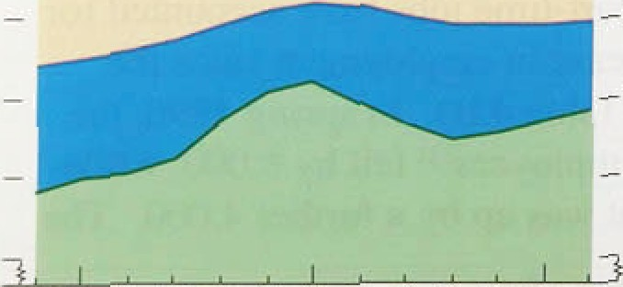

1. 2 S l of labo

The LFS provides an.estimate of:the .number of economically oclive people—that is, those in work and those actively seekkiinng wwoorrkk. T:hat iISs one measure of labour supply, but there are others. The *potential* supply of labour could, in .fact, be larger as some economically inactive people.of working age could be drawn into,the labour marhet vere suitable.vacancies.to arise.,! Potential supply may be.more relevant,.over the medium term.

Chart 4.2 shows the:population of working age by,labour market status, Thattis an upper bound on potential labour supply as some qconorrilcâlly inactive people of workifig age, such as the long-term. siok; do.not. contribute to potential sup.ply: But others;.i!nclu‹iing some:.of those.in education and.all .those discouraged from seeking work by’the stay of the j/ob.market„are po.iential .members of the labour:force.



*Tke labour market*

**Chart 4J**

**Potential labour supply**





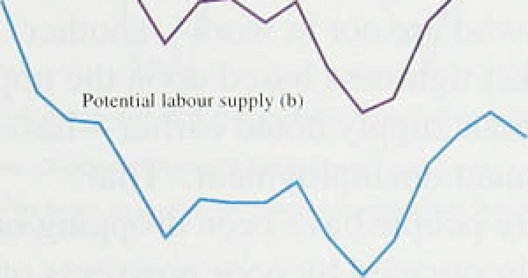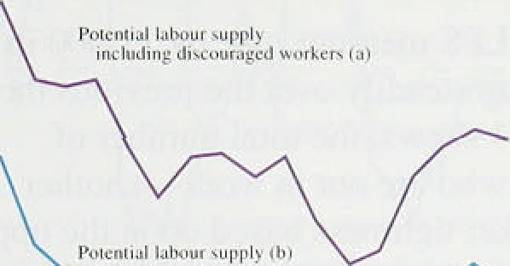

—

— 950



As when measuring labour demand, the total potential supply of *hours* is more relevant than the number of workers available. There are different ways of measuring potential hours supplied. One simple way is to: add actual hours supplied to estimates of the additional hours which those involuntarily in part-time work would be prepared to work and of the hours which those who are actively seeking jobs would be willing to work (see Chart 4.3). i Although the approximation of

hours offered is crude, it suggests that the number of

hours people would potentially be prepared to work increased in 1995, before stabilising in the first half of 1996. The chart also presents an alternative indicator that includes ‘discouraged workers’ in the estimate of the potential supply of hours. Discouraged workers are people who would like to work but have not looked for a job in the past four weeks, because they believe that none is available. That shows a similar picture.

Higher education affects the potential labour supply. The proportion of people between 16 and 24 in full-time education rose only gradually from 17.2% in 1984 to 19.9% in 1988. but then increased sharply to 33.4% in 1995 and stayed at that rate in 1996. The Department for Education and Employment (DEE) projects that this proportion will remain steady until 1998, so the supply of labour will probably not be affected much by changes in the number of students over the next few years.

Demographic trends also influence potential labour supply. These are estimated by the Government Actuary’s Department and the DEE. These sources project a rise in the population of working age of 0.36% a year between 1996 and 1998—in line with .its

long-term average, but not as fast as the rise between 1985 and 1987, the same stage of the previous cycle, when it rose by 0.53&r a year. So potential labour supply is unlikely to expand as fast ovet the next two years as it did in the mid 1980s.

## 3 eas s o bo a ket t t ess

.In: the short run, the interaction between the supply and d mand for labour determines the tightness of the labour market. In the longer run, it determines real wages.



’:pcrt-time Mrs;, 25.%:.of men.'and 1046 of womcn sa'td. tbey. wou\d prefer io



.eitiployeg!iv, hn'.i roiild



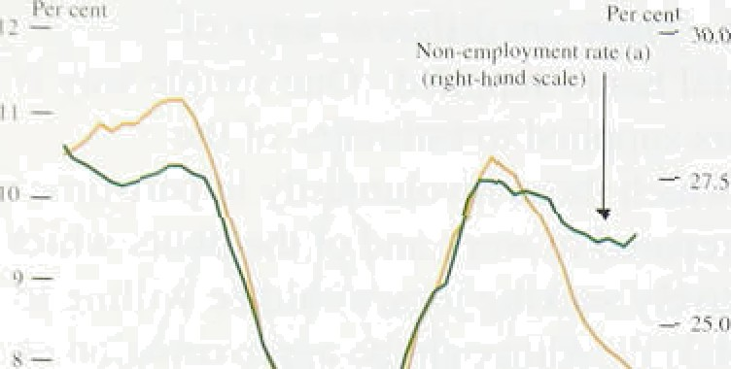C1‹iimant unemployment fell by an 1average, of 1 1.,600 a month in the three months to,J.une to reach 2, I 52.000. In the three months to Mai ch—the latest data available at the time of’ the May *.Inj’lcilion* Report—unemployment fell by an average of l 6,300. However, that is not sufficient to prove that the labour market, has been, tightening,

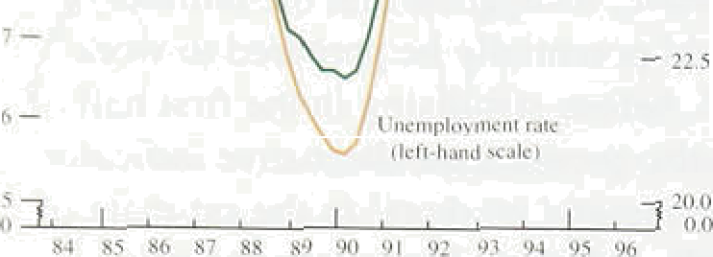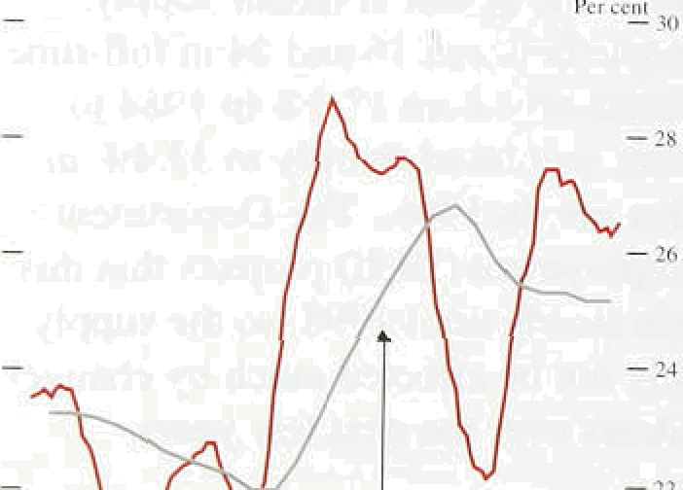Unemployment on the LFS measure rose, by I 1,000 in spi ing 1996, after f’alling steadi.ly over the previous three years. And as Chart 4.4 shows, .the tota! .number of people of work ing age who are not in. work—another measure ot’ labour market tightness based upon the upper limit of’ estimates of labour supply noted earlier—has fallen by less than claimant unemployment. That suggests thai either more people have been dropping out of the laboui’ mnrket. discouraged. by poor prospects of finding a job, or that more people .have lentered furthei’ education. Chan 4.5 shows that the proportion of the population of working age without employment has been tall.ing over the past three years. It also shows that

non-employment is still significantly higher than its eight-year avei age another measure of labour market tightness.

A better indication. of the state .of the labour market is the estimated balance between the potential supp!y of hoiirs and those hours worked, shown in Chart 4.6. The chnrt suggests that the labour market tightened. between the beginning of 1993 and the. middle of 1995, but .has

.not tightened since then. I.f discouraged workers are i.ncluded as potential suppliers of labour,. the resulting picture is similar.

Whi:le the estimated bal:ance. between. hours worked and hours offered.show.s no. tig past ylear, there are two indi’cators which lead.,to:!a different.view: skill shortages ,arid vacancies. N!either .piece of evidence is particularly stroiig. i.SkJl:l shortages. in manufacturing rose between autumn 1952 und.spring, 1595; they

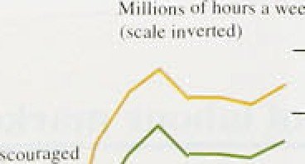

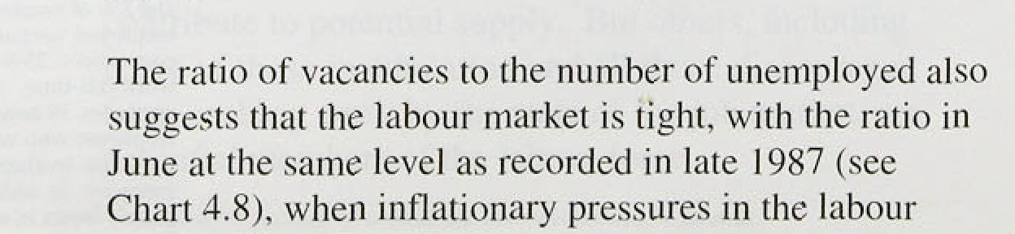.subsequentl.y fell:slightly before rising ifi,the !a!.est quarter according: to the CU! I:uly Quarterly Industrial. Trends ,Survey,(see Chart 4:.7). But the Britisli Charriñers. of Commerce Survey suggests recruitment difficulties are rriore of,a concern: .in' services and, man ufactur,ing; ;they 3re at their. highest si.nce !lS90.





**Chart 4.7 Skiil shortages**

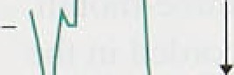



— 25

— 20

market had been building up strongly. The relationship between unemployment and vacancies has changed, however, and is no longer a good measure of labour market tightness, That is discussed later.

On balance, therefore, the labour market probably stopped tightening at the beginning of 1995, when GDP growth slowed to below trend.

## 4 4 Rec e e o a ed







Chart 4:8

**Vacancies.as a. propiirtion of unemplo2'ment**



— — 4



1980 85 90 95



Table LC

**Recoveries**







Table 4.C compares changes in employment, unemployment and inactivity as a share of the total working-age population in the first .four years of the recoveries of the 1980s and l990s. In the 1990s recovery. claimant unemployment *fell* by 1.2 percentage points of the working-age population, compared with a *rise* of 3.2 percentage points .between 1981 Ql and 1985 Q l—a similar period .over the previous cycle.

Employment fell in both recoveries, but by a little less in

the 1990s. However, the proportion of people neither employed nor actively seeking work—the inactive—rose sharply in the 1990s, .after falling by 1.3 percentage points during the previous recovery. Almost the entire net improvement in unemployment performance in the 1990s compared with the 1980s was accounted for, therefore, by the rise in inactivity.

The structure of employment also changed. In the 1990s recovery to date, service sector jobs increased by 3%. while those in manufacturing declined by 49c. This compares with an increase of 4'» in service sector employment over a similar period in the early 1980s, which was more than offset by a fall of 149c in manufacturing employment.

This shift into service sector jobs may have depressed measured aggregate productivity growth, as service sector productivity—as measured—is lower and increases less quickly. Between 1983 and 199 that is, between years which came two years after the previous troughs in output—average productivity in production 'in;iustries increased by 669, while average service sector productivity increased by 13&.

N l ea n s

’’ **Nominai** underlying aveiage:eami:rigs growth per:wotker

###### increased frorn J'/4 .. in Doember .t9.3 3f•& in February,

: **where tt:remained in** March and April: **.It..fell. back** to

###### .3'/i in May, âs expectnfi..





The pick-rip in average earnings growth in February can t›e accounted for’ by an ,increase in wage drift rather than settlements. Wage drift captures factors. such as .bonus payments, overtime,. shift. premia, grading increments

.ind changes in the composition of the workforce. Chart 4.9 shows that. between.January and April 1996, wage drifl contributed ‹Ill of the 0.5 percentage point increase in avei age earnings growth. The three-month u•inployment-weighted mean settlement recorcied in the Bank’s database was 3.49r in .June, up .from 3.3% in April, but lower’ thin it was .at.the start of l99ñ:

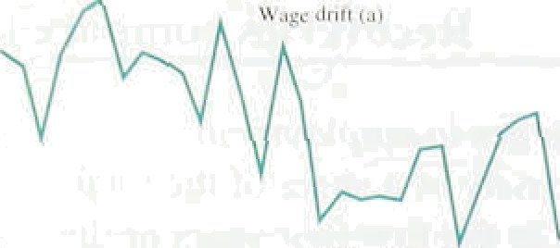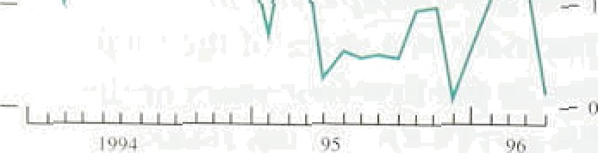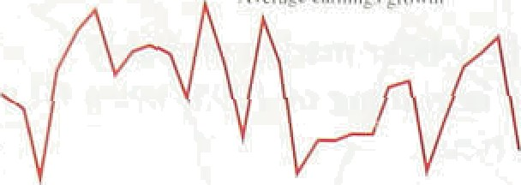



I.27?



7,(l.;!J





I ,794



A breakdown of earnings by .sector suggests that the .rise in wage drift in Febi’uary was concentrated in services.

.Bonus payments in the financial sector were much higher to spring 1996. than spri!ng 1995: income in financial companies rose by 3% i.n 1994 and then by l S7c in 1995. The effect of higher wage drift then dropped out of the twelve-month average earnings.



c ilculation in May. One factor pushi.ng up. bonus payments—and wage drift—over the longer term could be the rapid increase in profit-related. pay (PRP) .over the past ter years (see Table 4.D). Many of these schemes pay out in the spring.

Expectations of future inflation, are central.to the outlook for nomina! earnings. Price. expectations, measured by the Barclays Basix Survey, have fal.len by around half a percentage po.int among most groups questioned over the past year—the general public, economists and trade unionists. The latest data..are diwussed in Section. 6.

**4.6 Explaining the behaviour of real**



### sea s

Real wages per worker have .grown less over the current "* recovery ' than over the:corresponding part of.the

_ previous upturn:(see .Chart 4.10), even though

_ unemployment started to fall:rriuch earli!er in .the!eurrent cycle.

One possible explanation,'for subdued Page.behavipur.in

„ the current recovery is a lower natural rate of

, unemployment than during the previous cycle At tlie

„ .natural rate of uflemploymerii; the:demand for labour

, equals the ‘effective’,supply of l’abour; ,that is,’the

nun er of hour3 i›f wotk demanded:by firms.at.a, given real product wage.equals the nuriiber:.of hours finns believe is being offereci to.them. Tate effectiye supply'of labour is less than the total supply on offer because. tlie.!



34

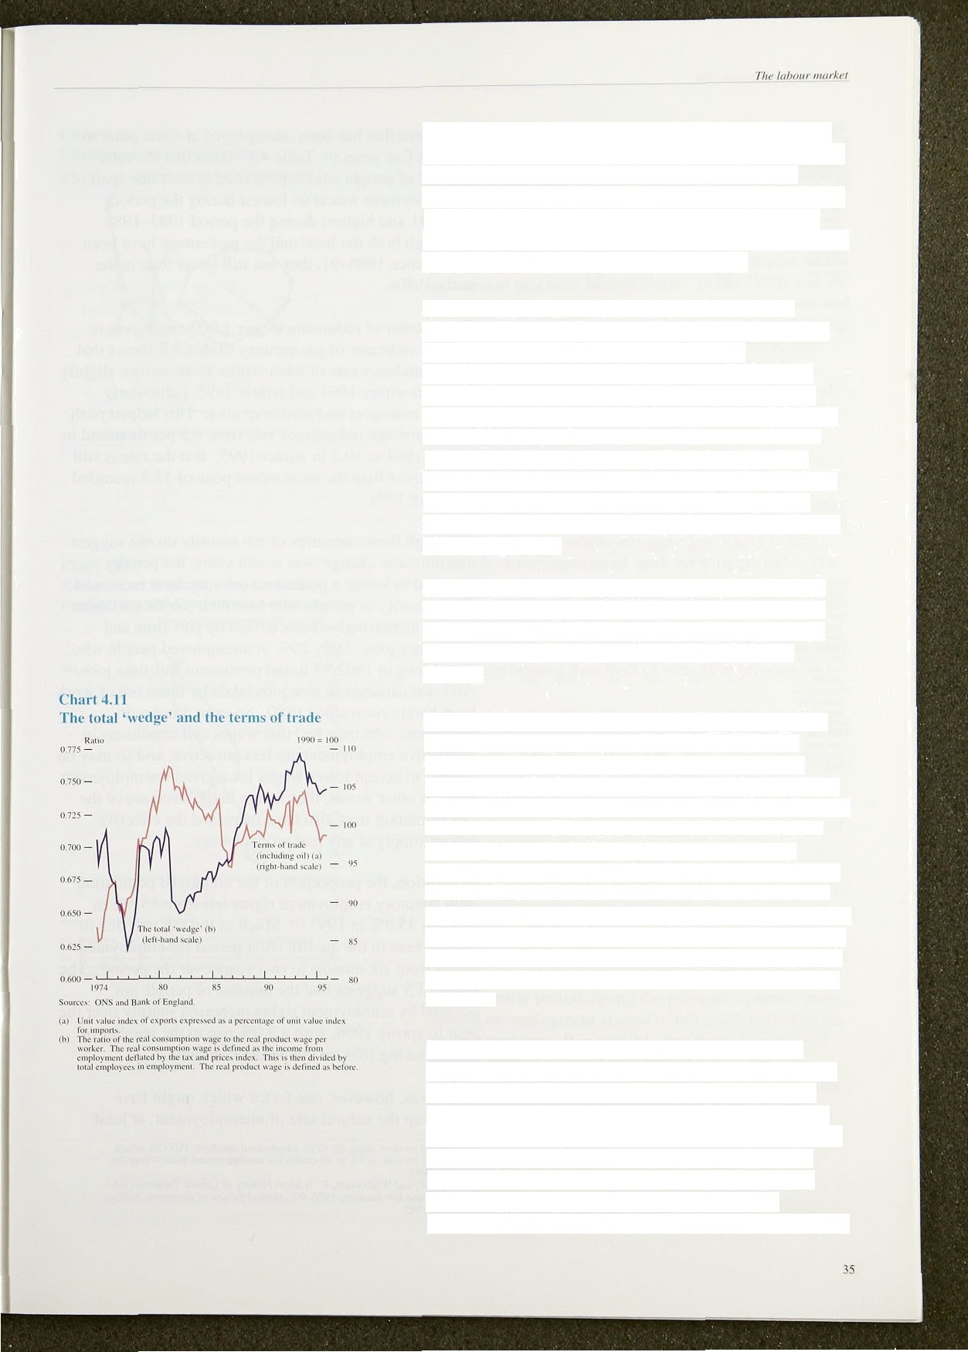labour market is not perfectly competitive—givin g rise to involuntary unemployment. Factors which may affect the natural rate include the level of unemployment benefit compared with the earnings of those in work (the ‘replacement ratio’), the degree of mismatch between workers and jobs, the institutions of wage bargaining and

the perceived job security of those in work.

Several factors in the 1980s tended to increase the effective labour supply at any given real product wage. suggesting that the long-run natural rate of unemployment should have fallen. According to the Department for Social Security, the proportion of the working population whose replacement ratio was below

0.7 increased from about 85% in 1985 to over 95% in 1996. By reducing the income available outside the labour market, a fall in the replacement ratio is likely to increase the number of people prepared to work at a given real product wage, and hence the number of hours effectively offered.

Other structural and institutional changes in the 1980s also tended to promote flexibility in the labour market by reducing trade union power and making it easier to hire and fire workers (see February 1996 *lnflatirw Report).*

A rise in the consumption wage relative to the product wage—the ‘wedge’ between them—would tend to increase the number of hours people are effectively prepared to offer for a given real product wage, because the benefit to an employee of an extra hour’s work would have increased. Chart 4.11 shows that the ratio of the consumption wage to the product wage rose fairly steadily over the 1980s, so that might also have reduced the natural rate. Two main factors affect the ratio: the terms of trade and taxes on income. The improvement in the terms of trade in the second half of the 1980s merely reversed the deterioration in the first half of that decade, and so is unlikely to have pushed the natural rate in one direction.

Increased job insecurity would also have tended to reduce the natural rate. Ifjob security had fallen—that is, if the risk of losing one’s job had increased—that might also have increased the number of hours people are effectively prepared to offer for a given real product wage. It depends on what employees perceive their opportunities to be if they are made redundant. The evidence on job security is mixed. One way of measuring job security is to look at the proportion of the

‹i i I i l›L' I ‹ ° l” }\I ‹ i}› IL' ill* k i i1j2 :tt l‹ .tel ‹ i Ut' ‹ lii i m I'r›j











«nivhin«



woi’ktoree that hus been unemployeci at some point in the p‹ist five years.' ' ' Table 4.E shows that the total number ot people who experienced at least one spell of’ unemployment was at its lowest during .the period

‘I' d ilYld highest tluriny the period 1983-1988. Although both the level und *the* percentage have been i‘ising since 1986—91 , they are still lower than in the early l9S0s.

The number of redundancies per 1,000 employees is another indicator of job security. Table. 4.F shows that the retlundancy rate of white-collar workers rose slightl.y between winter 1954 and w inter 1995, particularly

anit rig manager s and administrators. This helped push tip the avei age redundancy .rate frorn 5.5 per thousiind in winter‘ ! 994 to 10.2 in winter 1995. .But the rate is still much lowei’ than the most recent peak .of 17.5 recorded in spring 199 I.

Although these .ineasui es of joh security do not suggest any dramatic change over’ recent years, the penalty attached to losing a permanent job may have inci’eased. The minority of people .who. lose thei.r job face a .labour market increasingly characterised by part-time and temporary jobs. Only 20% of unemployed people who. found jobs in 1992/93 lr und permanent full-time jobs. ° And real earnings, in new jobs taken by those out of work have barely risen. si.nce 1980. So even those with permanent jobs may feel that wages anfi. conditional in alternative employment are less attractive; .and so may be willing to accept lowér wages fair a gi:ven unemployment rate. In other words, .the change in thel structure of.the labour market may alslo have increased the effective labour supply at any real product wage.

In additi.on, the proportion .of the emplpyed population with statutory employment rights tel.l from 'i5.5%. *in* 1975 to 35.9% in 1993. *) Much of the fall. was due,to. the increase in .the qualification periodlfor enployment rights from six months .tO two ye'd'rs over the .period. The latest LFS .suggests that ,the number of people .not covered by employment.rights increased shar'ply.!over.the year to .spring 1.996, wi.th a.3.0% .rise in'the.number of. people taking Jubs on temporary,.contracts. .

Thei’e was, however, ofie factor which might have pushed up the natural rate of:unemployment, at least"





Cbaft 4:1fi

Uneindlotioent-.vacannes **curi'e!**





 





Unemployment..os u pciccninge of touil ernpleyment

Chart 4.13

Real product wages adjusted for trend productivity and **short-term** unemploymenti•›

Trend'in mat u nii wuj;e c'ons, 1990:'= 100 {bi



1996' (é) — 89



•

* -

temporarily a fall in the effectiveness with which the unemployed look for jobs. The relationship between unemployment and vacancies is known as the ‘Beveridge Curve More effective job searching reduces the number of vacancies for any given level of unemployment and vice versa. The effectiveness of job search depends not only on the jobseeker, but also on the recruitment practices of employers. ln the 1960s and early 1970s, the relationship between unemployment and vacancies was fairly stable, btit, in the second half of the 1970s and particularly the first half of the 1980s. the curve appears to have shifted out (see Chart 4.12), suggesting that the effectiveness of job search declined. It then started to shift back in 1993. The increase in the vacancy rate for any given unemployment rate was probably linked to the proportion of long-term unemployed. The relationship between real wages and *short-term* unemployment was reasonably stable

between 1983 and 1993 (see Chart 4.13). That might have been because employers were less likely to hire those who have been out of work for long periods. The proportion of people out of work for more than a year rose from 349a at the beginning of 1983 to 439a in 1987 Q3 before falling slightly. Indeed, the increase in the proportion of long-term unemployed over the 1980s may have overwhelmed the effect of structural reforms.

.Demand for labour—measured by hours worked—has not increased over the past few quarters. Measures of labour market tightness which take into account hours worked suggest that the labour market has not tightened since the middle of last year.

.

'Nominal underlying earnings growth increased to 3’/‹'to

in February and that rate in March and April, as bonuses were higher this spring than in spring 1995; it fell back to 3'file in May, as expected. But real earnings growth has been lower over the current recovery than over a similar period during the previous upturn—even though unemployment started to fall much earlier in the current recovery. It is possible that the natural rate of



.unemployment is lower now than it was in the late

.1980s. That explanation would become more plausible if the subdued growth .of real product wages were to persist.

P t1988);”’ Unemp1oy;meal, Vacancies



**.Pxicing behaviour**

This section. reports.on pricing behaviour i:ri various. sectors of the economy. It is i.mportant to. recognise that the supply-side factors ‹discussed here primarily affect

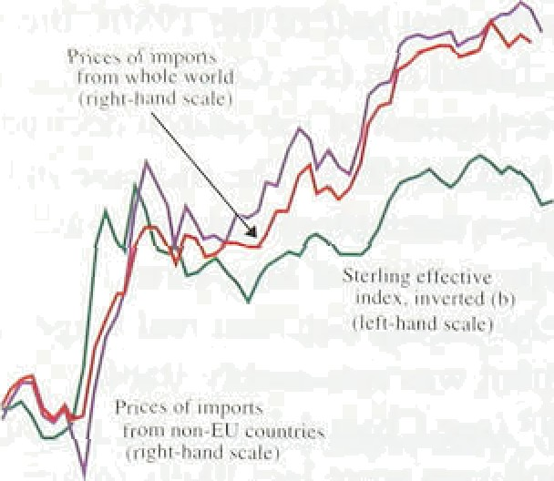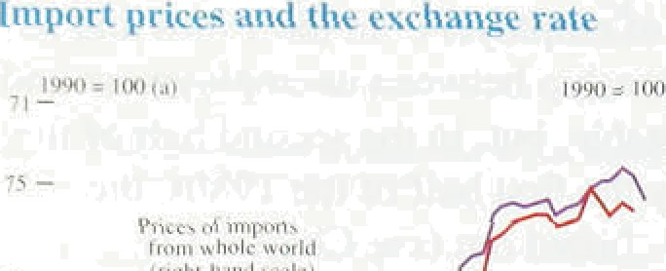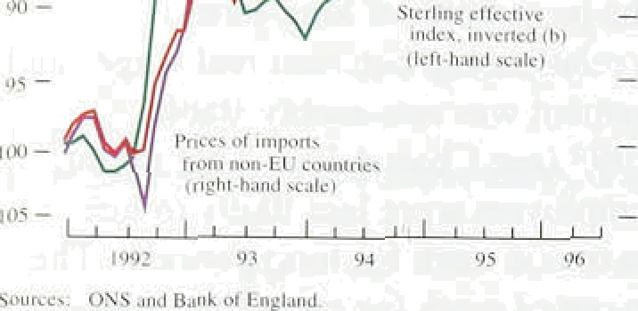

„

_

_

-

„, relative prices. They only have an effect on.the general price level in the long run..i.f monetary policy accommodates them, and in the. short run. if there are nominal wage and price rigidities.

### 5 l I t i es nd the e han e ate

Import prices accelerated.in the early part of blast year, but subsequent rises have been Inodest. The

' twelve-month rate of inc ease was just 1.7% in May,

„ compared with a peak of I .I.0% in August 1995.

Movements in the price of foreign currency are part of the explanation (see Chart ñ.1); .sterling depreciated. in 1995 Q1, but the effective index has!changed l.ittlc since then. It averaged 85.6 in March 1595 and 85.7 in July



 1996.

### a5m2 R w te ia d es

C.html â 2

Hii nd sterlitip e‹nn rnndit›' pricr index

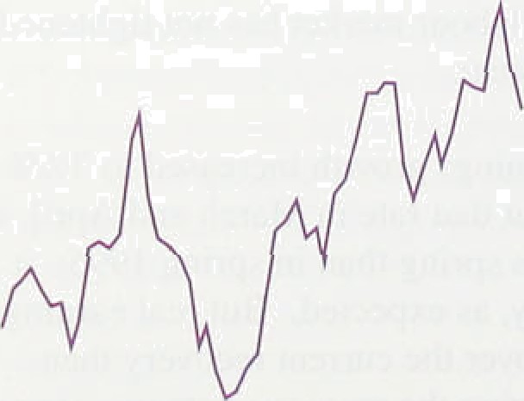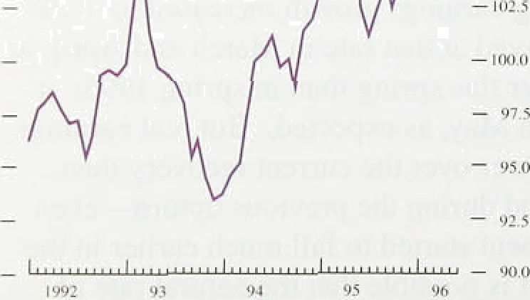





38

Following their sharp rise during 1994, sterlirig commodity prices have not been .a source of upward inflationary pressure (see Chart 5.2). In the year to December 1954, the Bank’s UK demand-weighted commodity price index rose .by 5.1%. Over the next 18 months, the annualised rate of increase was just. 1.8%. below RPI, RPIX and RfiIY measures of retail price inflation.

Non-perishable commodities—priflCI@ally metals,, fuel and.ti'mber—make up around 60% of the Ban1i!s. index. Chart 5.3 shows how their.relative'grice has.ténded to rise and fall with estimates of **GDP** growth in tlie G7. But market expectations of future1supp1y'.and demand conditions are also relevant, because.investors. wlio: anticipate an increase in.pride wilt aim to buy ad‹iitional.. stocks now, even though storage cos;s mean their tiine horizon..lean be slion. The May,..R‹rpo’r.i”notefi'thail comniodity price. pressures!.might re-emerge following: news. aboutistreiig.thehing.aétivity in the .United. States.

.and.Japs. In tire efiéñt copper prices:fell .sh l.y,.

.following the di.sclosure’of unexpected losses, by the Siimifoino .Corporation. This accouñted fñr most’:of the recent decl ne.in the Economist index (see inset.chart):



,US wheat prices rose by 209a or so in March and April añd were noted as an upside risk to retail prices in the May.Report. Subsequently, weather conditions improved so that, by the end of July, the price of winter wheat had fallen a little below levels seen around the turn of the year. Bakery products are only a small part

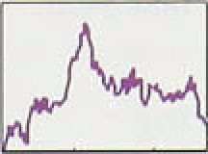

- •.

'

of the RPIX basket and the impact of this temporary price rise on measured inflation has been small.

C DP.griwth fhl' - • 5bu3t

## ri in

on nd st es



Sources:' Biinlt for lntcinoiional Seine rncnis. The Economist:Ind





**Chart 5.4**

**Producer price inflation**



— 7.S

— — 5.0





ChaE 5.5

hipiit prloe Inflation and: the Cn s purchase

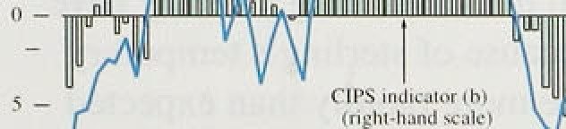prlce.Indicator







-.40’



Manufacturers’ input costs fell by 2.09• in the twelve months to June—a marked change from the high rates of increase seen at the beginning of last year (see

Chart 5.4). When purchases of the food, drink. tobacco and petroleum industries are excluded. the level of input prices has declined for eleven consecutive months.

A survey by the Chartered Institute of Purchasing and Supply (CIPs) also reported that raw material costs have fallen this year. Its price indicator fell to 37.7 in July, the weakest number since the survey began five years ago. The index is calculated as the percentage share of manufacturers reporting an increase in the price of their purchases, plus half the share who experienced no change—so outturns below 50 suggest falling prices. These data are a useful indicator of input

price inflation prior to the publication of the ONS series (see Chart 5.5).

Annual output price inflation was stable at around 4'/ % in the second half of 1995, but fell steadily during the early part of 1996, reaching 2.6&o in June. In May, the ONS introduced a new output price series that excludes excise duties—analogous to the RPIY measure of retail price inflation outlined in Section 1. The new output price series rose a little more slowly in the early part of this year than the headline index (see Chart 5.4). Taxes increased faster than the prices charged by manufacturers for their output.

Table 5.A provides short-run inflation measures, which illustrate the recent weakness of cost pressures in manufacturing industry. Output prices barely rose in the first half of 1996., It seems likely ,that many firms, faced with weak demand and possibly an overhang of unwanted stocks, decided:not to charge more a view éxpreesqd in reports fmm the frank’s Agents. More evidence is, provided by the CBI Quanerly Industrial Trends survey, irt:which..man.ufacnirer8 are asked not oily to descnbe pricing decisions over the past.four



months, but also to outline .p”lans: for.the future:.



Chai’t 5.6 shows that respondeiits, on lbalânce,. ha‹i more difficulty than .usual iii achieving ‹tesi.red loufput price

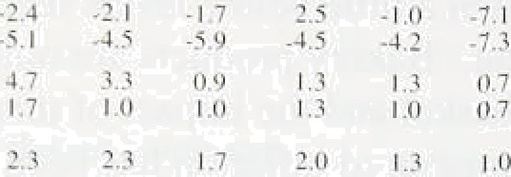

*‹ises* frorn the middle of last year.

 lnput-output .tables can be used to al.locate the variable costs o.t pi’oduction in rtninufñeturing.to one ot four sources. In l *185 labour costs represented around one halt’ of the total, and w.ere the single riiost important c;itegory. Raw malerial and fuel inputs accounted .for



.around one quarter. Imports of finished. rriaiiqfactures



and bought-in services, sucti as transport costs, made up the reniain‹ier. ln 1995, weighted. unit costs rose more rapidly than output pi’ices (.see Tablg 5.B). But the i‘everse was true in the thi ee rñonths to May, compared with the previous three.months... Manufacturers may

.ha; e seen a .modest improvement .iri. margins, is pi’oductivity .growth increased and .raw material costs continued to fall.

#### 5 P c n b reta e s

A proportion of retailers’ costs is aCcounted for by pm’chases of UK-manufactured pro‹iucts. That explains why.rates of output and retai.I price iliflation soriietimes. move together. But there .is. no mechanical. link from one to the other. Retail prices also <refiect.other cost components—notably labour and..imported goo‹is—and

 the prici.ng t›ehaviour of i.ndividual fi.rms.

The Bank’s centi’al projection for inflation assurnés that increase‹i competitiori has led. to.a structural fal.l. in retail inai’gins. But there is a risk that. firms may try to, expand: their margi.ns as consumer demand. continues to arise,.thus offsetting weaker cost .pressures..from.iiianufactufing industry.



Despite signs, of greater activity in’the world ecorio.iny,



prices. :Cost pressures in rfianufacturing industry havé eased further—=pa tly. be.cause of ster1ing*s teinporary appreciation and..a little store.!rap.id1:y than expecte‹i ttiree. inonths ago. Outpct prices bârdly .rose in the first. six months of 1996, i.n part a:reflection of weak demand.



a:7 4S I

4.7 I ’ -t7.



.Lower'retai.l.price iiiflation inay. follow,..’but only if other cost c:omponents do not accelerate and retailers’ margins. rerñain.unchanged. ’



* 1. **Developments in prices, aggregate**

### d a d

Real GDP has grown at a rate of around '/ % in each quarter since fhe *begi* n*ning of* 1995, a little below the long-run trend. As a result, the output gap may have widened a little. Spare capacity and unemployment in the economy have been exerting downward pressure on inflation. The rises in the relative prices of imported commodities and semi-manufactures in 1994. followed by a depreciation of the nominal and real exchange rate at the beginning of 1995, led to a temporary rise in the twelve-month inflat’ion rate, from 2.09 in October 1994 to 3.1&r in September 1995. As that effect began to wear .off, **RPIX** inflation fell slightly ; in June, it was 2.8%. Producers’ input prices are now falling and their domestic output prices are increasing very slowly.

The evidence of a change in the pattern of UK growth mounted in the past quarter. Although real GDP grew by 0.4% in each of 1995 Q4, 1996 Q1 and 1996 Q2, real domestic demand accelerated. Its quarterly growth rate doubled between the last quarter of 1995 and the first quarter of 1996, and the signs are that the pick-up. particularly in consumption, continued in the second quarter. Retail sales volumes grew by l.3% in Q2, more than three times as much as in Q1. Consumer confidence improved in the quarter, and the CBI Distributive Trades Survey confirmed the pick-up in retail demand. The strength of consumer demand was reflected in further increases in house prices and a slight pick-up in activity in the housing market: turnover, net lending secured on homes, new mortgage commitments, and reservations on new homes were all higher in Q2.

.Private investment, like consumption, accelerated in the first quarter of this. year.

Looking ahead, it is likely that domestic demand growth will **increase** further and will begin to be reflected in nlgher output growth—above the long-run trend—in the seoond half ofi this year and .into 1957. Consumption growth **is.likely to be** stimulated!by **several** factors,

**:incle‹iing faster .growth .of riâl** pre-tax earnings, lower

 **income ian:rates** and **income gearing on personal sector**

##### debt, and'ahigher leveL of financial wealth in relation In.



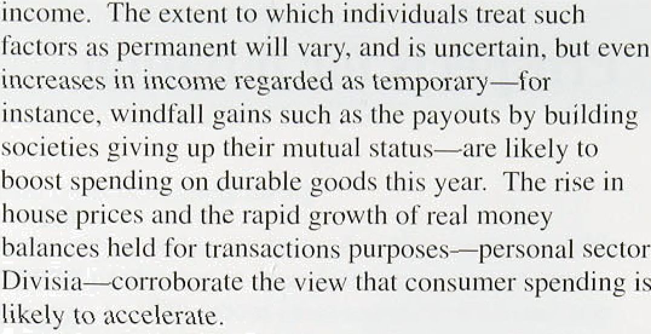

Investment is also likely to increase, although it is normally more volatile than consumption, and the timing of any further recovery is uncertain. Although the profitability of ICCs has probfibly fallen this year, their stock market valuation has increased faster than the prices of index-linked gilts, implying that higher profit rates—and a higher return on investment—are expected, not just lower real interest rates (see Chart 6.1). More manufacturing firms than last quarter expect plant capacity to constrain their output. .Some industries may not share in the expansion: HM Treasury’s Sum.mer Forecast projects general government investment to fall further, and there is little sign yet of any .recovery in

.investment in non-housing buildings an‹i works. B,ut the  rapid growth of corporate sector M4 deposits, like that of

personal sector deposits, is consistent with an

acceleration of spending.

Accelerating domestic demand will stimulate activity and narrow the output gap. Net trade is likely to make a lower contribution to.growth than it did earlier in the recovery. If the increase in the pace.of growth persists in the medium term .as expected, upward pressure on inflation will develop and the output gap will close.

In the near term, the .two.main risks to that outlooh remain the behaviour of stockbuilding.and exports, as pointed out in earlier *Inflation Reports.* First, although recorded stockbuildinglhas fallen back since 1995 Q3, there is still a downside risk to output because the aggregate stock-to-sales ratio has risen, against the

‹downward trend seen since the early I.S80s (see Chart.3.9). Increases ,tn colnsiitiip on ringlet b1e satisfied

.from existing stocks, leaving output growth temporarily subdue‹i;, and:invest ment miiay be postpoqéd until stoek°to-sales ratios have been *educed, The risk is exacerbated by tire .possibility that stockbuilding has been underrecorded a potenti:a1 explanatioii: for the **ONS’** sptisticâl‘âdjustrfient **which!!aligns** ou@nt-baseil and arpenditure-baiéd easures of GDP. :But many or



r, „y„., r.. ,.y ‹.»

the siocks way now be held will ingly, in anticipation or’ a further acceleration of domestic demand. Surveys and reports from the Bunk's Agenf do n‹›t suyycst that unwanted stocks are a widespread problem. Thus  stockbuilding has been consistent with the centi’al projection and output gi Owth has nt›t been der ressed much below trend. The dt›wnside risk i.s less than in

May, but is nevertheless still present.

The second near-term risk ct nccrns UK export markets: prospects for demand growth in continental Europe remain uncertain. A recovery i s likely this year. but the downside i’isk—less than in May—is that it lnight t‹ike longer to arrive. As with stock building, evidence about net exports in the tirst quarter was broadly ctinsistcnt with the central projection in the May fi‹•J›r›i i. Ciross exports grew more rapidly than expected, partly because first-quarter GDP growth in the G I I) ( UK

trade-weighted) was stronger than expected. But import growth was surprisingly high, too, given the stocks of goods held by UK manufacturer’s.

Those short-terrn risks affect the timinR of the acceleration of demand. Two medium-term risk s uffect the impact of demand on inflation.

First, real wages have grown more slowly in the l990s than the l980s. One of the risks to the central projection is that a change in the relationship between unemployment and real wage growth might. for’ a given monetary stance, lead in the short i un to lower wa_•e and price inflation. Real product wages—the cost to the tlrm of employing a worker (deflated by the GDP deflator at factor cost)—rose at an annualized rate of under Imc between 1992 Q4. when unemployment peaked. and 1996 Q1, despite a fall of over 700.000 in claimant unemployment over that period. If the risk materialised, wage settlements would fall, doinesticall y q•enerated inflation would be lower than expected, and the scope for non-inflationary output expansion would be greater.

A second supply-side issue is the behavIour of margins. Changes in margins can lead to one-off chances in the general price level when there is imperfect competition in product markets. Margins depend on three main factors: the degree of product-market competition. the state of the business cycle and firms’ tendency not to adjust selling prices as soon as particularly volatile costs change. Increased competition among retailers has helped to bring down retail margins in the past four years; they started out higher than in most other countries. so the decline will probably be sustained. But





RPIX infIati‹7n projection in Mxj'



The clan shuns itw.ret*tiye likclilmd nf possible outcomes.. The cciural baud. coloilred deep icy, includes ihe central projccii'on: th'erc is;jqdged: tt› he ahnut a I0Nr chsnce thus inñation \yi1l he u!ithin th*f ccntral band.:at an'y.date.: The.next deepest.shade„ nn both.sidés.of the central: band, .‹akes Ih« dirtr ihuj run unit t‹› 2U’1 : and sn on, in steps ‹›f tan perccn\age puints. .Of course, it .is i in'pursih|e .to assess' the probabilities with any .precision, h\it this reprcsci\\8 the £l;ink's best estimate. The mnrc unce.rtain\y thore is about.the.inftation outcome”al. any #articu]ar.ttrrie. horizon, the .wid'er thc



side ol the ee'ntral bund.

the risk is that the ,decline,lias been. w.rongly attributed to a lasting increase in. co;mpetition. and ans.tead took place because levels of demand were. low. or.selling.prices were adjtistin.g slow!y to cost increases. Neither of those two factors are.expected.to persist:

### The B:ank’s medium-term inflation Jo e t n

The Bank’s medium-term projection of twelve-montñ

.RPIX. inflation is shown in Chart fi.2, néxt to lastlMay’s

.projection, shown in Chart.6.3, , Official i'nterest.rates are

.assumed:to remain unchanged over.the next two.1years, andi!the sterling elective exchgnge..rate is assumed to

acrosea n i s

R d

al .publ

e t

n ing and eJ ee vata

rates are proj1ected:to follow the profiles set out’‘in HM

: Treasury's Su.mmer Porecast.. Chan 6.2 shows the Bank's assessment of the probabil!ity! diytributioii fo’r inflanon outtums, iii order to. emphasise.the degree of uncertainty.surrounding them. The central projection liea .in’the ntral band—the one witli the darkest



shading. In the Bank’s judgment, there i s about a I *t)"7r* chance that inflation will be within that band at any time. The probability goes up in steps of ten percentage points as successively paler bands are added on both sides of’ the central one. The more uncertainty there is about int)ation at any particular time hoi’izon, the wider are the bands and the more gradually the colour fades. If the risks are more on one side than the other, the bands *are* wider on that side.

Chart 6.2 shows that, according to the Bank’s assessment, the most likely path is for twelve-month RPIX int)ation to fall until around the middle of next year, and then to increase gradually. It is likely to fall below 2 '/:*Zc some time later this year, but to return above that level towards the end of the forecastinp• period. The fall in inflation in the near term is consistent with the current degree of spare capacity and unemployment in the economy, and the unwinding of supply shocks from imported in put prices and the exchange rate around the beginning of 1995. Inflation is expected to increase subsequently, as the result of the above-trend growth first of nominal domestic demand. and then of output, in the second half of this year and continuing into 1 997.

Compared with that presented in the May *Refiorf,* the

current central pi’ojection—which is extended by one quai ter to 1998 Q3—is for slightl y higher int4ation. The main reasons for that increase are lower interest rates since May. the new Treasury forecasts for ta xes and public spending, and the slightl y

better-than-expected gross export performance in the first half of the year.

The risks around the central projection are distributed differently in the short and medium terms, as the shadinp• in Chart 6.2 indicates. In the short term, the downside risks still jusi outweigh the upside ones, even though the uncertainties about stockbuilding and recovery in Europe have diminished somewhat since the May fie/x›rf.

Further ahead, the risks are skewed towards the upside. as they were in May: it is more likely that several compoiJents Of domestic demand will pick up strongly at the same time than that some components will not increase at all. The supply-side tactoi's discussed above—the natural rate of unemployment and margins— increase uncertainty: the former raises the downside and the latter the upside risks. On balance. the chances of hitting the Government’s inflation target have fallen since May. and it is somewhat more likely than it was then that twelve-month RPIX inflation will be above 2'/29O in two years’ time if official rates remain unchanged during that period.

I )1:I I”1 f›.-I



#### 3 Other t on r ect o s

Most measiii es of’ inflation expectations monitored by the Bank h.me not changed much since the May *hijlaf ion Ref›i›rt.* The median forecasts for twelve-month RPIX. inflation in 1 996 Q4 are still 2.7% and, for inflation in.



'" 1 997 Q4, 2.9 Z‹ (see Charts 6.4 and 6.1). Those are higher th.m the Bank’s central pi’ojections. The interquartile range—the i ange of central projections

"' excluding the highest and lowest quarter s of the distribution—narrowed. to 2.59 —2.8% for 1996 Q4. Unusually. the spread of views for 1997 Q4 has not narrowed despite the .reduction in the forecasting. horizon: the interquartile range has widened ,slightly to

" 2.5 Fr—3.1°7r.

A subset of .foi’ecasters provided the Bank with the probabilities they attach. to various possible inflation outcomes (sec Table 6.A). The range of uncertainty âi’ound most forecasters’ central projections .remains similar to the i angel around the Bank’s. The average probability attached to **RPIX** inflation being 2'/:bo or below in 1996 Q4 is 457c (up from 40% in May): ror 1997 Q4, the ctirresponding figure is 33% (up from 31 %

- • in May). Those prohibit ities are lower than i.mplied by

* the Bank's projection in Chai’t 6.2.

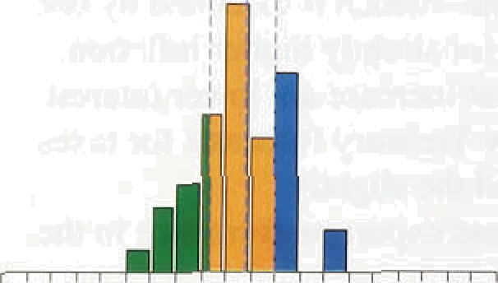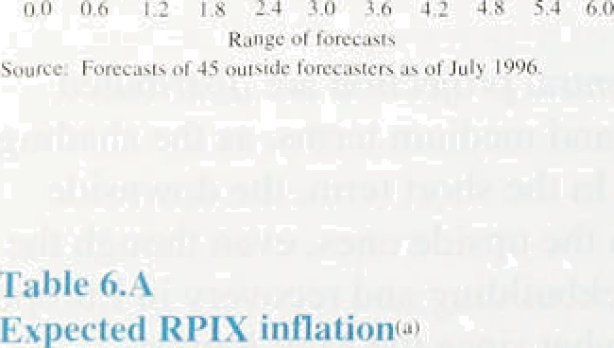

«1

‹ The inflation expectations reporteld in the Barclays Basix

* + Survey of different groups and the Merrill Lynch-Gallup

‹ survey o.f UK fund managers have changed very little, as Tables 6.B and 6.C show. The only change of nore than

0.1 percentage poi.nts since the previo‹ts. *Report* is in the expectations of trades union general secretaries about inflation in tw,o years time, which. have .fallen.

Expectations about i.nflation in the longer .term have fallen a little. since the May *Repnrt,* judging by the

ifideurended gldpr ces fCha:6.6),

ll

The suren

Tld

Us

‹h:ni

overestimate expected inflation if there is a substantial. inflation risk premi.um in the. y.ield.on cofiventlonal.gilts:. But they are .sufficiently above 2'/i%. to :suggest that there

.is stilil cofisiderable scept!icisin about.the..determinat-ion wi!th. which..price ,stabi'l!ity wi.11:be pursued. i.n..the long term: .Eveh. over a two-. ear horizon. ottier inflation projections and surveys .suggest that .the inflatioñ target is more likely to be mjssed.than! h:i.t.:



KOW

«›

2.v1

«›

tt'

'«



### 6.4

. . . . . ,

.Retai1,price inflation remains añove. the!Government s

target. :Bu.t.cost pressures are:very .wea!k—input prices,.



Tab1b 6.B

**’Barclays Basix fiuzwey expectations**



Tu'etve•mootb 8P1-ioftatlon one year akeaa

Mar.. 1996. Ju'ne.!996



3,0

3:0

Ngive-monih RPlariñetien iwo yeers ahead



excluding those of the food, drink, tobacco and petroleum industries, have fallen for eleven consecutive months. and earnings growth is .unchanged from the time of the May *Report.* The short-term prospect is for a funher fall in the inflation rate. As the increases in retail

prices last summer drop out of the twelve-month comparison, RPIX inflation is likely to fall below 2'/ % to within the target over the next six months or so.

Since the beginning of the year, the changing pattern of economic expansion has become apparent. Following

t3eneral public:



. Aoailumic econñmistx Tmdi unions.



Table 6.C



.36 34

4:0 4.0

4.2: 4:’1



departure from the ERM in September 1992, a rebalancing of monetary and fiscal policy—an easier monetary and a tighter fiscal stance—led to a lower real exchange rate and a shift of resources from growth of domestic consumption to net exports. and an export-led

recovery up to 1995. Over the past year, that pattern of

**JVferrill Lynch-Gallup 6urvey of UK fund**

rnanagezB

Percenlaye increases in.prices 3’,weIve•moath RPI I 99b

Inflation ist Mar. Apr. May Ju.rie. {^!Y

Eod- I9.96. 2:B 2:9 2.9 2:g 2.8

End;-)99? 3.2 3:3 3.4 3.4 3.4

'. 8o»fce: âXcrriII .LynchT*ulIvp.

recovery has been reversed. Excluding stockbuilding. domestic demand, especially consumption, is growing strongly and net trade is no longer making a significant contribution to output growth. As a result, service sector output has risen at about ’labo a quarter and manufacturing output has been broadly flat over the past year. The picture of accelerating domestic demand is reinforced by continuing rapid monetary growth and the outlook for the public finances.

**Eroplced forward inflation** rates‹°›





, „, For the current financial year, the general government " deficit is projected to be 4% of **GDP,** nearly two

„ percentage points more than anticipated only 21 months ago in the 1994 Budget (see Chart 3.13). In part, that

_ „ .reflects the fact that output remains below trend. In the longer term, however, such deficits cannoi be reconciled

*-* • with hitting the inflation target as well as maintaining a sustainable fiscal position.

Faster demand growth will. after a lag, stimulate domestic .output. Consumption probably grew at an annualised.rate.of 4&o or more in the first half of 1996 and there is every prospect of further rapid growth for some time. Business optimism has risen and other survey responses signal an increase in orders and activity. Annual real broad money growth has now been aboxe 5& for four gunners. Looking.ahead, output looks set tolacce1erate. Nevertheless. the short-term



risks to activity identified in recent *Reports—a* run-down in stocks and continuing weak demand on the Continent—meld back.growth in the first part of the year and have not yet disappeared.

##### Hence the Bank's latest view on inflation two years

:ahead shows a lcential.pix›jection for RPIX inflation a



l*t1aiion Report: August 1006a

little above 2'/2&c and rising, witli the risks more on the upside than the downside. That is.a slightly worse prospect than in May. In the near term the outlook for inflation is benign. But rapi‹i money growth will stimulate demand and output, reduce spare capacity and lead, ultimately, to higher inflation. Of course, ft is difficult to know when the upturn in money and demand growth will lead to inflationary pressures, and the major uncertainty about the central projection is the.question of timing. But the implication of the projection is that a tightening of monetary policy will be necessary at some point to achieve a better-than-even chance.,of keeping inflation below 2'/i&o in the medium term. With such a favourable short-term outlook—of faster growth and falling inflation—there is always a temptation to ignore the consequences of faster growth of money and activity for inflation until inflation itself has started to rise.. By then, however, it would be too late to prevent a sharper policy correction that would be more damaging to stability than an earlier pre-emptive .move.

48

# Glossary and other information

##### Glossary of selected terms

**RPI inflation:** inflation measured by the retail prices index. **RPIX inflation:** inflation *measured* by the RPI ezcludi >B mortgage interest payments.

**RPIY** inflation: inflation measured by the RPI excluding mortgage interesi payments and the following indirect iaxes: council .tax, VAT, duties. car purchase tax and vehicle excise duty, insurance tax and airport tnx.

**HARP index: a** price index which replaces the mortgage interest payments component of the RPI with a Bank estimate of the user-cost of housing.

’£uaaz'indez: the HARP index excluding indirect *taxes.*

MO: notes and coin in circulation outside the Bank of England and bankers’ operational deposits at the Bank.

M4: UK non-bank, non-building society private sector’s holdings of notes and coin, together with all sterling deposits (including certificates of deposit) held with UK banks and building societies by the non-bank, non-building society private sector.

**Divisia** money: a measure of the money stock in which each

COfI1 OJ2Bf1t IS W**Bhted according to an estimate of how useful are the transaction services it provides.

**SDR:** special drawing right. A basket of fi ve currencie the dollar, yen, Deutsche Mark, sterling and franc. Weights are reviewed periodically by the IMF.

**ICCs:** industrial and commercial companies.

**OFIs:** other financial institutions.

**BSE:** bovine spongiform encephalopathy. TEsSA: tax-exempt special savings account.

Three-month **annualized:** the percentage change in a series between one period and that three months earlier, expressed as an annual rate.

Syinbols and conventions

Except where otherwise stated, the source for the data used in charts and rabies is the Office *for* National Statistics (ONS .

The measures of inflation included in this *RePort* have been adjusted by ithe Bank for a ONS error in underrecording RPI and RPIX .inflation between February and May 1995.

not available.

— nil or less than half the final digit shown.

**Because** of rounding, the sum of the separate items may sometimes dffféf -kOm the total shown.

On the horizontal yes of graphs, larger ticks denote the first observation within the relevant penod, eg dafi8 fOr the first quarter of the year.

Other information

!Eiiiâil: rñadi.v3 &dircon.co.uk:



